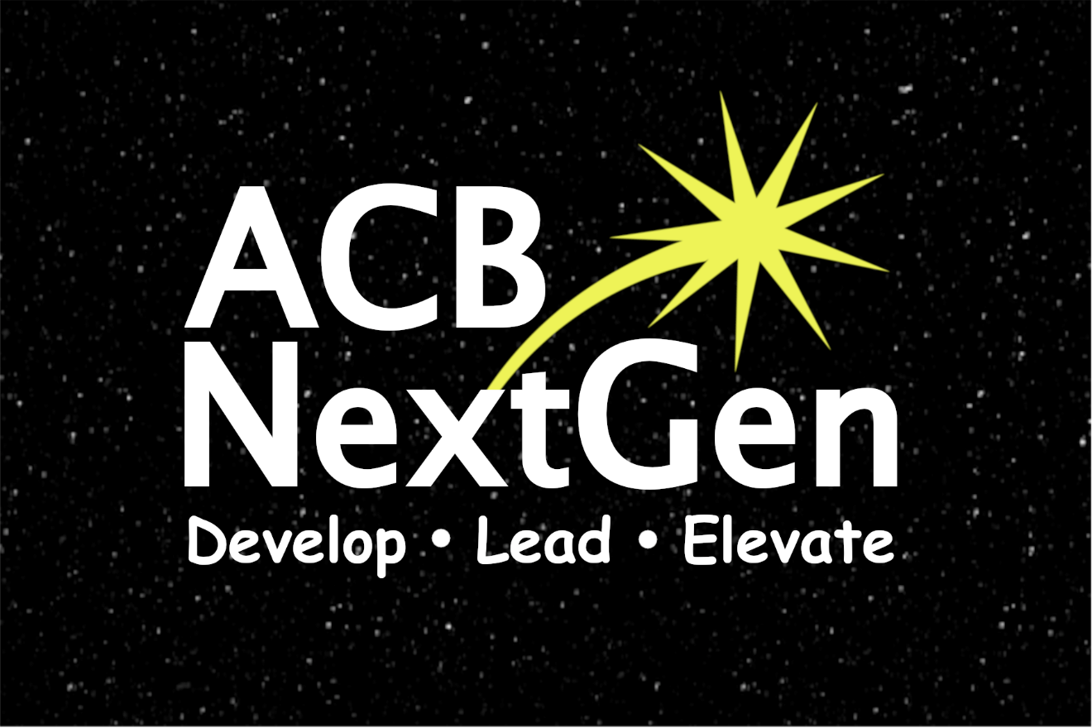

NextGen Insight

Volume 1, Issue 1
October 2021

Publications Committee Chair: Greg Lindberg
Table of Contents

President’s Message 1
Fundraising Corner: Brenda Dillon Memorial Walk Recap 4
2021 ACB 60th Annual Conference and Convention Recap - “Better Together Wherever We Are” 5
Member Spotlight Highlights 8
Members in the Limelight: Album Review 9
Members in the Limelight: Book Review 11
Hey Bombers…I Think We Are in Kansas! 14
Cane Usage Tips and Tricks 18
Self-Care for the Holidays: 5 Things You Can Do Daily to Take Care of YOU for FREE 19
Autumn Hour 20
Kay Nyne Private Eye and the Missing Spirit 21
Holiday Recipes 26
Affiliate News: Kentucky Council of the Blind Next Generation 28
Calendar of Events 30
ACB Next Generation Board of Directors 31
How to Reach Us 31
(NOTE: Page numbers begin after the Table of Contents.)

“May you have the hindsight to know where you’ve been, the foresight to know where you are going, and the insight to know when you have gone too far”
– Irish Blessing

***

President’s Message
Dear ACB Next Generation Family and Friends,

I am so excited for our first issue of the NextGen Insight. As our affiliate continues to grow and thrive, I would like to share some highlights from this past summer.

During the virtual 2021 ACB Conference and Convention, we successfully hosted and co-hosted a total of 21 events. However, I personally enjoyed our “Coffee and Convention” chats in the mornings and our “Late Night Hangouts” during the evenings on Clubhouse. This is where I had the opportunity to get to know the bulk of our new and existing members. I would personally like to thank Melanie Sinohui and our outstanding Convention Committee for all their hard work this year.

We received one of the ACB Affiliate Growth Awards for the highest percentage of annual membership growth. From March 2020 to March 2021, our affiliate grew by 136%, with a grand total of 42 new members during that time. Let’s race to the finish line and go for a second award. You, our members, are our best recruiters. Be sure to tell all your friends about our amazing affiliate.

This was our first year participating in the ACB Brenda Dillon Memorial Walk. After the final closing date of August 31, we finished in the Top 10 teams raising just under $2,800 which will be split 50/50 between ACB NextGen and ACB. Thanks to MOe Carpenter and the Fundraising Committee for promoting our team walk page and to everyone who joined or donated to our ACB Next Generation Allstars team. Because of you, we are one step closer to achieving our dream goals.

On August 5 and August 12, we held our annual Committee Showcase. This year, we split it into two parts so our members could ask questions and engage with our Committee Chairs. We had an excellent turnout for both evenings. As a result, 16 new members filled out our Committee Interest Form.

On September 26, ACB NextGen hosted “Sunday Edition.” Byron Lee and I enjoyed chatting with members of both ACB NextGen and the ACB Community about what ACB has unexpectedly done for them. It was encouraging to hear several inspirational stories from people of all different walks of life about how ACB has positively impacted their lives.

Looking ahead, I would like to invite you to mark your calendar for our Annual Business Meeting on Monday, December 13 at 8 p.m. ET with elections to follow. This year, we will elect five directors who will serve two-year terms on our Board of Directors. Please watch our email list and social media for more information in the next month.

As I wrap things up until our next issue, please remember to be kind to others. As we approach the holiday season, the best gift you can give someone is kindness. “Sometimes it takes only one act of kindness and caring to change a person’s life.” - Jackie Chan

Warmest regards,
Amanda Selm
President, ACB Next Generation

***

Fundraising Corner:
Brenda Dillon Memorial Walk Recap

Hello wonderful “Framily”,
This is your Fundraising Committee Chair, MOe Carpenter. I wanted to take a moment to boast about our amazing walk team this year. For those new to ACB, the Brenda Dillon Memorial Walk is an annual fundraiser for ACB held during the national convention, and this was the first year ACB NextGen had our very own team, the ACB Next Generation Allstars, and I have to say, we hit it out of the park for our first walk team.

The ACB Next Generation Allstars raised $2,808.22, bringing ACB NextGen $1,404.11 in funds to start some amazing programs for our still very young affiliate. This may include tech grants, non-traditional student scholarships, and convention and conference assistance. We had 19 individuals donate to this year’s “fun run” and I think it’s safe to say we hit a home run for our first year. We are looking forward to next year when hopefully we will have an in-person component to the walk.

As our team was among the top earners during the walk event at convention, we earned several gift cards. Since we feel so strongly that we are a “framily” here in ACB NextGen, we only took one gift card for our walk team and gave the rest to the board to distribute for other events.

Our walk celebration took place October 7, 2021, and we drew Annie Davis as our gift card winner. To Annie and all our other generous supporters, thanks so much for believing in ACB NextGen, and we can’t wait for next year! In fact, planning has already begun.

Moe Carpenter
Fundraising Committee chair

***

2021 ACB 60th Annual Conference and Convention Recap - “Better Together Wherever We Are”

By: Melanie Sinohui
ACB NextGen Convention Committee Chair

As most everyone knows, the week of convention is crazy and at the end, oftentimes a blur. We meet new people, reunite with others, and share both traditional and new experiences. Many do not see what goes on behind the scenes months, and in some cases years, beforehand.
The 2021 ACB NextGen Convention Committee, made up of the hard-working Shane Aguilera, MOe Carpenter, Annie Davis, Aaron Espinoza, Winter Renfrow, Amanda Selm, Melanie Sinohui, and Gregg Wandsneider, started planning February 9th to put on the show many of you witnessed and participated in during July.

ACB NextGen had a total of 58 registrants, up from the previous year. We planned 21 programs ranging from socials and networking opportunities to our spearheaded events on learning in a hybrid environment, non-traditional blind sports, smart home devices, content creation, Space Camp for Interested Visually Impaired Students (SCIVIS), and our pre-banquet fun playing Who Wants to be a Millionaire 90s edition. Plus, we had the pleasure of partnering with seven different affiliates and committees throughout the week.

I also wanted to call out what appears to be our most attended event, which was our partnership program with the Council of Citizens with Low Vision (CCLVI) for the Work Smarter, Not Harder event on smart home devices where we had 97 people in the Zoom room plus our listeners on ACB Media.

Through generous donations, we were able to give away 10, $10 Amazon gift cards for door prizes throughout the week with a grand prize door prize of a $50 ACB Mini Mall gift certificate.

This year, we tried out new technology in utilizing Clubhouse for our morning Convention and Coffee meetings to share the events of the day and our after-hours socials after the planned programming for the day was completed to discuss the day and build new relationships with members and non-members alike, all over the globe. We also utilized acbnextgeneration.org as a one-stop shop for registration, membership, and event information and are excited to continue using these successful avenues and exploring additional ideas for next year.

Check out www.acbmedia.org/podcasts to play the podcasts from events you attended and hear any content you may have missed.

The 2022 ACB NextGen Convention Committee has been selected and is excited to start planning for our hybrid convention. ACB's 2022 National Conference and Convention will be held July 1 - 8, 2022 in Omaha, Nebraska at the Hilton Omaha. We certainly hope to see you there
***

Member Spotlight Highlights

There is no “I” in “team.” ACB Next Generation is a team as strong as its membership. Our membership is full of people with passions, talents, and goals for a better and brighter future. These are the up-and-coming leaders in ACB.

Winter Renfrow is the committee queen from Kentucky with a passion for social work, mentoring, and supporting other visually impaired parents. She is a full-time volunteer, advocate, and mom. She has been a member of ACB for about six years and looks forward to a future where blind parents are more widely accepted and plans to add her voice and experience to that cause.

Shane Aguilera hails from Hollywood and has been a member of ACB since 2018. A newer member, he is still finding his voice (with perfect pitch) in ACB. He is financially forward thinking and is interested in fundraising and investing. Music and connecting with others make him smile and look forward to speaking up for ACB Next Generation.

Kaila Allen is a creative crafter from Arizona. She has been a member of ACB Next Generation since 2020. She runs workshops for crafts and other activities for Future Insights. She is living her dream of making crafting accessible for people with visual impairments.

These are just three of our ACB NextGen members. Through music, crafting, parenting, and advocating, they are finding their voices and making this next generation a better one.

***

Members in the Limelight: Album Review

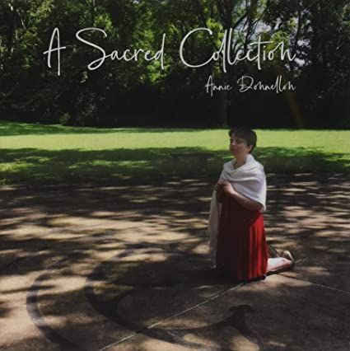
A Sacred Collection: Annie Donnellon

“Sacred to me is something that is meaningful, close to my heart and because of my Catholic upbringing, I wanted to honor that. God gave me all the songs that are supposed to be on this album. All of these songs are one’s I have loved to sing through the years and are favorites of my friends and family.” - Annie Donnellon

Annie’s album is available on Amazon, Spotify, Apple Music, and on your favorite streaming service. You can also purchase directly from Annie by sending $15 to her at www.paypal.me/anniedonnellon (please include your address). The CD also has Braille liner notes which you can request directly from Annie.

(Image Caption: The front of Annie’s CD cover. Annie is wearing a dress with a shawl and kneeling with her hands together in prayer surrounded by trees.)

***

Members in the Limelight: Book Review

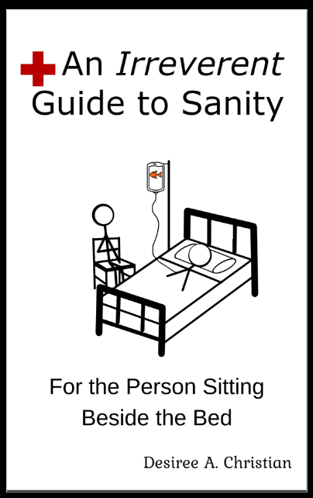

Medical Crisis: An Irreverent Guide to Sanity
For the Person Sitting Beside the Bed
By: Desiree Christian

This book is intended for the uninitiated person that finds themselves sitting next to your loved one’s bed for the first or fifth time. There are many of us who have blazed a trail before you, you can do this! Just remember to breathe. Otherwise, you might find yourself in the bed next to your loved one.

This book is also intended for those of us who sit beside the bed who, like our loved ones, have become unwitting frequent flyers. I can’t speak for the rest of you, but I found myself, more often than not, staying quiet in the many waiting rooms as I never knew where a person’s headspace was at in that moment. I wonder which hospital will offer the first frequent flyer mileage plan.

This book is also intended for the medical staff and professionals who are so often shortchanged in the amount of time you have. Service to all the variations of humanity can be interesting on some days and curiously interesting on others. I am grateful for the delightfully dark and irreverent humor I can share with most of you.

After living through one daughter coming a hair’s breadth away from dying on four different occasions before her 15th birthday and the other daughter having 38 surgeries by the time she was 12, I am sharing with you several tips and tricks I have learned over the last 20 years so you can determine the right level of freaking out to do depending upon your current level of crisis (e.g., the difference between your loved one having a broken leg vs. sudden and unexpected loss of limb).

I hope when you read this book, you will learn what to expect when you have a medical crisis, you will gain the courage to gracefully handle particularly difficult medical professionals, and the wherewithal to use what small moments you are given to take care of you; all while injecting a bit of dark humor here and there. If you cannot find a bit of levity when the s*** hits the fan, I might suggest you may perhaps, just a tiny bit, be taking life a hair too seriously. From personal experience, your body will kick your a** at the most inconvenient time and place if you don’t take care of yourself.

Check out my website for links to my books, updates, and to join the email list at https://www.irreverentguide.com.

(Image Caption: White book cover with a drawing of a stick figure child laying in a hospital bed and a stick figure adult sitting in a chair at the side of the bed. Above the image is the title. Below the image is the subtitle and author’s name.)

***

Hey Bombers…I Think We Are in Kansas!
by: Greg Lindberg

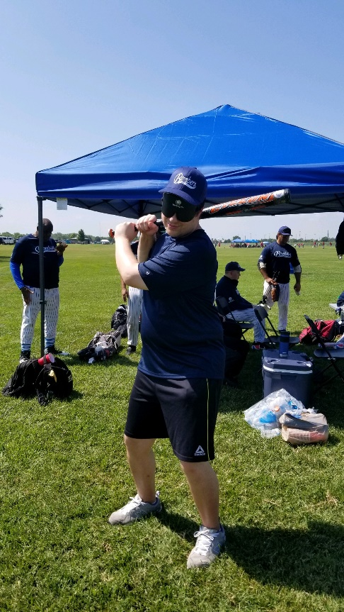

Attending the National Beep Baseball Association World Series has become a bit of a summer tradition in my life. This year’s tournament was extra meaningful since the event was cancelled in 2020 like mostly everything else. Being held in Wichita, Kansas, I couldn’t help but muster up thoughts of Dorothy, Toto, and the rest of the cast of characters from The Wizard of Oz as hundreds of blind and visually impaired people from around the country ascended on this spot in the nation’s heartland the last week of July.
I’ve had the opportunity to compete on several beep baseball teams at the World Series, including the Daytona Bats, Athens Timberwolves, and Braille Bandits of Palm Beach County. This year, I was offered a spot on the Long Island Bombers. I have to thank Casey Bahn, my teammate on the Bombers whom I had previously played with, and Alex Barrera, the team captain, for this invitation. Launched in 1997, the Long Island club has been an occasional top-10 performer at the World Series throughout its history and is certainly the most talented bunch I’ve played with in my beep baseball career. Due to life events, some regulars couldn’t make it to Kansas this year, so our team was projected by the “experts” to finish around 14th place out of 19 clubs.
The first day (Tuesday, July 27) was a rough go of it. We dropped games to the Chicago Comets, Austin Blackhawks, and Gateway Archers. On the second day, we started off with a 5-1 victory over the Lonestar Roadrunners. We then ran into a buzzsaw against the Indy Thunder, the league’s dominant club for several years, but concluded that day with a sweet 5-1 win against the host club, the Wichita Falcons.
On Thursday, we earned a hard-fought win against the Philly Fire, 4-3. We then suffered another loss to Austin. In the final game that day, we had our most exciting contest with a nail-biter versus the Bayou City Heat. The seesaw battle left us trailing 3-2 in the bottom of the sixth inning. (Keep in mind beep ball games are traditionally only six innings.) We then tied the game at three before Alex, our captain, came up to score the game-winning run in walk-off fashion, 4-3. We all went bonkers considering how Bayou City has been a championship-caliber team in recent years. In our final game Friday morning, the Archers knocked us off again.
We ended up with a 4-6 record in our 10 games, a mark good enough for the No. 10 spot in the rankings. This was several spots higher than some had anticipated, so we were thrilled with this result. In addition to our matchups, I got to attend the championship game this year for the first time between the Indy Thunder against the San Antonio Jets. Much like our game with Bayou City, it was a back-and-forth affair. With the Thunder trailing 7-6, Corey White smashed a walk-off home run to capture Indy’s fifth-straight World Series title with its 8-7 victory. (In beep ball, a home run equals two runs.) This was certainly the most thrilling game I had witnessed in person and seeing a local TV news truck parked at the field made it feel that much more special.
As always, it was refreshing meeting so many new faces and networking on several fronts. With aspirations of developing my own beep ball team here in Florida, I got some tips and tricks on this and even connected with someone from the Atlanta Chaos, a potential opponent for my future team being in the southeast. I also hit it off very well with my roommate, Edgar “Tiger” Erickson, who lives in Manhattan and works as an interpreter at the famous Bellevue Hospital.
I highly recommend anyone who has the slightest interest to try an adaptive sport like beep baseball to give it a shot. It’s an incredible opportunity to meet people, network, get some exercise, and enjoy the camaraderie of playing a team sport. When you’re out in the field or up to bat, vision loss temporarily doesn’t mean a darn thing.

(Photo Caption: Greg Lindberg practices his batting stance outside with his left leg in front of his right and the bat resting on his right shoulder, ready to hit his next home run.)
***

Cane Usage Tips and Tricks

By: Aaron Linson

This article aims to be shorter than the rest. It is written to provide you with some tips, tricks, and tools on using your mobility and orientation skills. If you have any tips or tricks of your own, please let us know.

Why should I look at getting my cane a few inches taller?

There are a few different reasons people choose to do this.
- They are fast walkers and need a cane to pick up more of what is around their environment.
- Some people just want a bit longer of a cane because they feel that being right at the middle of their chest is too short.

It’s all about preference and what you like. Please talk to your Orientation and Mobility Specialist to find the right sizing for you. I have also found that if I am ordering a cane from Ambutech that if I know my size, the representative is pretty good about knowing the right cane height for me.
***

Self-Care for the Holidays:
5 Things You Can Do Daily
to Take Care of YOU for FREE

By: Amanda Selm

1. Wash your face in the morning when you wake up, and in the evening before you go to sleep.

2. Drink at least 64 ounces of water. Water is good for the body, but it is also good for your skin, and it is good for your mental health.

3. Exercise at least 30 minutes. Move as much as you can, as frequently as possible.

4. Go outside. You need natural Vitamin D, even if it is just for 5 minutes.

5. Take time for yourself to reflect, relax, and recharge before you take on a busy day.

***

Autumn Hour

By: Daisy Russell

Empty eyed fields
Full of old bone brittle grass,
And lifeless leaves tumbling into nothing
Lead to a house in the woods,
Dark and untamed.

Its rooms are dusted with time,
Its walls shadowed,
Ghosts always drifting in the drafts,
Its spiders always weaving,
While the mice dance and crows command the wind.

A lost spinning wheel
Runs nowhere,
Whistling and squeaking in fear.
A broken sleigh hides in the barn,
And a ship sits in no water but dusk,
Forever sailing across a blood-streaked sky.

A wild road traps the house,
Embracing an old orchard bent and broken with age,
Crab apples creaking in the breeze,
Limbs too tired
And peeling smiles staring down death.

This is the autumn hour,
The hour before winter’s icy blow,
A time when everything is fading,
Crumbling,
And slipping away to sleep,
Wrapped in the blanket of freezing night.

***

Kay Nyne Private Eye and the Missing Spirit

By: Desiree Christian

It was a dark night in October. Piles of pumpkins gave warning that a night would soon arrive when clusters of costumed children would roam free with their parents trailing behind as mere afterthoughts.

Seymour and I were finishing up a few notes from our last case when my ears perked up as I heard footsteps near our front door. The bells jangled.

“How may we be of service?” I heard Seymour asking our potential client.

“You don’t look like Kay Nyne.” a hyperactive voice stated.

“I hope not. There would be an awful lot of inconvenient explaining to do.”

I could hear the gentle teasing smile in Seymour’s voice.

I met Mr. Seymour Braille several years ago when I accidentally hired him for a position I didn’t know I needed. With an incredibly sharp mind, the exceptionally tall white cane found it particularly problematic working in his expected profession of guiding the blind.

My red oxford heels tapped on the wood floor as I stepped from my office.

“How may we help you?” I asked a very worried looking koala.

“My spirit has gone missing!” exclaimed the koala.

“You seem pretty animated to me.” Seymour replied.

“Not my spirit,” the koala paused in exasperation, “My spirit… from my front yard.”

Behind our front counter, I raised an eyebrow.

“Do you mean an inflatable lawn spirit?”

“Yes!” our future client exclaimed.

The white-furred koala dressed as if no one ever told them no.

Fee negotiations completed and important papers signed, Blane K. Paige left us with the impression disaster would befall us if the inflatable wasn’t found ASAP.

About a block away from our client’s house, Seymour and I queried a gaggle of wand waving kids on the whereabouts of a spirit. Initially peels of giggles and laughter were heard. When we inquired further, pointing to our client’s house, the wee wizards glowered and frowned in its general direction.

As we approached our client’s front lawn, Seymour spied a tiny round door inset into a tiny grassy knoll.

Kneeling in front of a gorgeous tiny garden, I rapped gently with my manicured paw on the tiny round door. A Norwegian bachelor lawn gnome introduced himself as Boblington the third. We inquired as to the whereabouts of the missing spirit.

Puffing his pipe, Boblington rocked back on his heels looking up at us.

“Well, the horseless horseman, being new in town, attempted to scare those young wizards to no great effect. As to Blaine’s spirit? Not sure they ever had one.” Boblington thoughtfully replied.

Spying Blaine K. Paige’s garage door open, Seymour and I shared a look.

“Might as well.” I stated.

We thanked Boblington for his time.

My black tail swished as I stood brushing off my pencil skirt. My nose twitched as Seymour and I entered the garage. A peculiar smell of inflatable plastic rubber mixed with a rare scent, indeed, wafted through the room.
Nestled between an antique wooden box labeled “Bits” and a vintage wooden box labeled “Bobs” was a crystal case with the letters E G O carved into its lid. Clearly seen through the lid lay a deflated spirit.

I called Blaine K, Paige on my smartphone.

“We have found a spirit in your garage.”

Torturing my canine hearing with an amplified and tinny version of reality seemed redundant, so I hung up the call hearing the agitated koala rush through his house.

Figurative fur flew from our koala client as they entered their garage. Seymour and I glanced at one another ignoring our client’s angry threats. I pointed to the no longer missing inflatable spirit, noticing a small button on the case labeled ‘inflate’.

When Blaine K. Paige picked up their crystal case, the once deflated spirit started pounding on the inside of the case’s lid, making little rhythmic tinkling taps.

“Leave my property. Your services are no longer needed or welcome.”

So, we did. Last I saw there were a gaggle of wee wizards and a Norwegian bachelor gnome gazing mirthfully while a screaming Blaine K. Paige was being chased by an ever-growing spirit hurling insults, I can only assume to inflate itself. I may have “accidently” brushed the ‘inflate’ button on the crystal case with the letters E G O on our way out of the garage.

***

Holiday Recipes

Sweet Potato Souffle (with topping)
Bertha Pritchett (Alyssa Jolley’s grandma)

Souffle Ingredients:
3 cups mashed sweet potatoes
2 eggs (beaten)
1 stick margarine
1 cup sugar
1/2 cup sweetened condensed milk
1 teaspoon vanilla extract
1/2 teaspoon salt

Topping Ingredients:
1 cup brown sugar
1 cup chopped nuts
1/3 cup flour
1/2 stick butter or margarine

Directions:
1. Mix the souffle ingredients together and pour into a greased baking dish.
2. Mix the topping ingredients thoroughly and sprinkle over the souffle.
3. Bake for 35 minutes at 350 degrees.

Marzipan (Almond) Pound Cake
Melanie Sinohui

Ingredients:
7 oz. almond paste
1 cup granulated sugar
1 cup butter
4 eggs
1/2 cup milk
1 teaspoon baking powder
2 cups sifted flour

Directions:
1. Beat paste, sugar, and butter until light and fluffy.
2. Continue beating and add each egg, one at a time.
3. Add flour, baking powder, and milk. Beat until smooth.
4. Grease and flour your bundt pan. Fill pan 2/3 full and bake at 350 degrees for 1 hour and 10 minutes.
***

Affiliate News:
Kentucky Council of the Blind Next Generation

By Benjamin Wright, President

I am so thrilled to be writing this article for the first-ever newsletter for ACB Next Generation. My name is Benjamin Wright, and I am the third President of KCB Next Generation. We are a chapter of the Kentucky Council of the Blind. KCB Next Generation received its charter at the 2014 state convention.

Our chapter likes to keep itself busy. We meet twice a month; on the second Thursday we have our monthly business meeting and on the fourth Thursday, we have a special program. Our programs are held virtually since we all live in different parts of the state. Most of our members live in Louisville, but some of us, including myself, live in the western part of the state. Our programs include educational topics like traveling with a disability and organization tips to just hanging out and catching up. Over the summer we had one in-person hangout where we were able to socialize and enjoy a cookout. I wish we could have more in-person meetings, but the rise in COVID-19 cases has prevented us from doing so. We are hopeful that we can gather together again in person soon. Many of us haven’t seen each other in so long.

Finally, I would like to get you all excited for our upcoming state convention. It will take place from November 18-20 and will be streamed on ACB Media. Everything is still in the works, but I promise you it will be a wonderful convention. I hope you all can tune in.
***

Calendar of Events

Everyone is welcome to attend these events by accessing the Zoom mobile app, visiting the Zoom Web site at https://zoom.us or calling (312) 626-6799, and entering the appropriate meeting ID and passcode.

You may sign-up to receive reminders and Zoom details by subscribing to the ACB Next Generation email list. Please send a blank email to main+subscribe@acbnextgeneration.groups.io

In addition, many ACB NextGen events are listed on the ACB Community Call schedule.

October
30 - Saturday Night Live Hangout - 7:00 PM Eastern

November
4 - Fireside Chat - 9:00 PM Eastern
9 – ACB Next Generation Board Meeting - 8:00 PM Eastern
27 - Saturday Night Live Hangout - 7:00 PM Eastern

December
2 - Fireside Chat - 9:00 PM Eastern
13 - ACB Next Generation Annual Business Meeting - 8:00 PM Eastern
TBD - Saturday Night Live Hangout - 7:00 PM Eastern
***

ACB Next Generation Board of Directors

President – Amanda Selm
1st Vice President - Matt Selm
2nd Vice President - Steven Salas
Secretary - Greg Lindberg
Treasurer - Maria Kristic

Director - Moe Carpenter
Director - Aaron Espinoza
Director - Byron Lee
Director - Nicolas McNeill
Director - Onkar Nerurkar

***

How to Reach Us

Email Address: ACBNextGen@gmail.com
Phone Number: (202) 524-0909
Web site: http://www.acbnextgeneration.org
Social Media: http://www.acbnextgeneration.org/contact-us

The NextGen Insight is published four times a year:
(January 15, April 15, July 15, and October 15) in digital form via email and posted to our Web site the following month. Send contributions to ACBNGNews@gmail.com.

