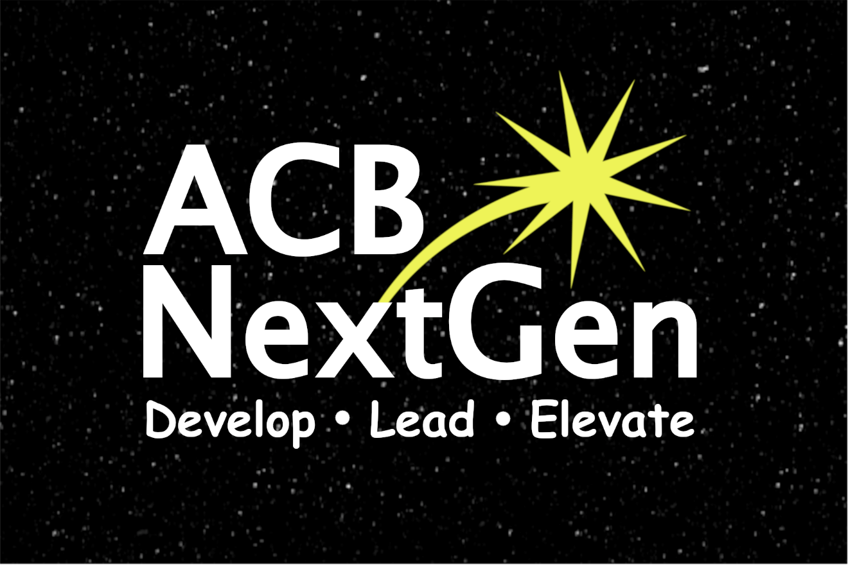

NextGen Insight

Volume 2, Issue 2
April 2022

Publications Committee Chair: Greg Lindberg
Table of Contents

President’s Message 1
ACB Conference and Convention Update 3
Door Prize Contributions 8
Brenda Dillon Memorial Walk Registration Open! 10
Fundraising Committee Update 11
Call for ACB Next Generation Cookbook Recipes 13
Affiliate News: Kentucky Council of the Blind Next Generation 14
2022 DC Leadership Experience 14
Mother’s Tribute 15
Memorial Day Tribute from ACB Next Generation Members 17
National Craft Month Creations 18
Book Review 23
The ABCs of Financial Health 25
Calendar of Events 32
ACB Next Generation Board of Directors 34
How to Reach Us 34

***
Title Page Image Description: Background - Black night sky with dim stars in a horizontal rectangle. Foreground - All text is in white font. NextGen spans the width of the image with the N and G capitalized. ACB is in capital letters above the word Next. A yellow star is shooting out of the top right corner of the letter x and hovering over the word Gen. Underneath and spanning the width of the word NextGen are the words Develop Lead Elevate (1/3 of the font size of ACB NextGen) with a dot between each word.
““In today’s complex and fast-moving world, what we need even more than foresight or hindsight is insight”” – Anonymous

***

President’s Message
Dear ACB Next Generation,

Happy spring to each and every one of you reading our newsletter. Spring is one of my favorite times of the year. There are so many wonderful holidays to celebrate, the weather is changing, the earth comes to life by sprouting colorful plants, and best of all, the excitement begins to build for events like the ACB Conference and Convention and the ACB Brenda Dillon Memorial Walk.

Are you planning to attend the 2022 ACB Conference and Convention? On April 1, the ACB board of directors voted to hold a hybrid convention. If you are unable to make it to Omaha, you can still participate virtually. Mark your calendars and set your alarms because convention registration opens on May 12 for ACB members. Our Convention Committee is hard at work planning some fun and informative events. Be sure to watch our email list and social media for more information.

If you know me, you know that I love to win. Last year, we hit a huge milestone with the ACB Brenda Dillon Memorial Walk by finishing in the top five teams by the ACB Conference and Convention. We also raised just under $3,000 for last year, and this was our first year participating. Let’s set the bar a little higher this year to finish in the Top Five by convention and raise $4,000. Did you know that our affiliate receives 50% of the money we raise from this event? Imagine the possibilities and opportunities for our affiliate. Everyone can help our ACB Next Generation All-Stars be a winner by joining our team, making a donation, and/or sharing your love for our affiliate with family and friends and asking them to consider making a donation.

Since our affiliate family enjoys gathering together, a special membership meeting will be held on Monday, June 6 at 8pm Eastern, 5pm Pacific. This meeting will serve as an opportunity to provide a midyear update and get everyone geared up for all the summer fun. It’s been a tradition the past two years for our “NextGen Framily” to gather during the month of June for a time of connection and recognition.

As always, I want to thank you, our members, for spreading your sunshine. Because of you, we certified 108 members on March 30. This gives us four affiliate votes during the ACB Conference and Convention. Thank you to our Membership Committee for their hard work making sure that our new members feel welcome and keeping our records up to date.

To conclude my message for this issue, I felt compelled to share this quote with you: “Kindness is spreading sunshine into people’s lives regardless of the weather.” - Raktivist

Warmest regards,
Amanda Selm
President, ACB Next Generation

***

ACB Conference and Convention Update
By Melanie Sinohui
Convention Committee Co-Chair

Welcome to Omaha!

On Friday, April 1, the ACB board of directors voted for the 61st annual ACB conference and Convention to remain hybrid. Convention will look different this year. The hybrid convention opens in Omaha, Nebraska on July 1, but the actual convention will open the weekend before (starting June 22) and will host many affiliate business meetings as well as virtual-only events you'll want to check out.
Registration opens for ACB members on May 12 and non-members on May 19. It will close on June 20 and open on-site on Thursday, June 30. Member cost is $35 and $50 for non-members with a $10 additional cost if either registers on or after June 30. You will also see the option to register for individual affiliates. The registration cost for ACB Next Generation is $10, in addition to your convention registration, but that will enter you into all of our door prize drawings, provide you with our convention swag bag, and that money helps offset our expenses.
We'll be updating the ACB Next Generation Neighborhood on Facebook and acbnextgeneration.org through May, June, and July to keep you apprised of all that's going on. During convention, we'll have daily morning Clubhouse coffee hours and we'll be sending out information daily to the ACB Next Generation email list.
For those of you looking to come to Omaha for any part of the convention July 1 through July 8, be advised you will have to show proof of your Covid-19 vaccination or if unable to be vaccinated due to religious or health reasons, a negative Covid PCR test will have to be taken 72 hours ahead of your arrival. Masks will not be mandatory for convention attendees, but volunteers and hotel staff will be required to wear masks when interacting with the convention. There will be sectioned-off areas of convention meeting rooms for those who want to wear masks and sit with others who they know will be wearing masks. As far as outside of the hotel and convention center, we will follow the guidelines the City of Omaha has in place at the time of convention. If you have any questions, please wait for additional convention information to be released with contacts provided by the convention committee of who within ACB to reach out to.
Below is our current schedule of convention events; however, there may be more to come. Keep an eye out for the Registration Packet as well as on our email list and Facebook to see the latest events we are organizing and promoting.

We look forward to spending time with you all, whether in person or virtual. This is always a great time for our affiliate to network and build up momentum for the coming year. If you have any questions, please email Melanie Sinohui or Cassie Trosper, Convention Committee Co-Chairs at acbnextgen@gmail.com with “2022 convention questions” in the subject line.
Current Convention Schedule
(Convention event times are in Central Daylight Time)
Saturday, June 25: 5:30pm-7:30pm
ACB Next Generation and ACB Students Pep Rally (virtual only)
Who’s got spirit? We do! Let’s get fired up for the 2022 ACB Conference and Convention. Join ACB Next Generation and ACB Students for our Convention Pep Rally. Enjoy meeting new friends, fun icebreakers, and learn about all our amazing events as well as important information you will need to make your convention experience, whether virtual or in person, a great one. Bring your favorite snacks and get ready to root for ACB 2022. We can’t wait to cheer with you!
Friday, July 1: 8pm-10pm
ACB Students and ACB Next Generation's Friday Night Bash (in-person with a virtual event after)
Grab a friend or two and join us for a lively evening of icebreakers and group activities as we mingle with members, friends, & our supporters! You might even win a door prize or two! Join in the fun as ACB Students and ACB Next Generation open the 2022 Convention Week! Keep an eye out on ACBS’ and ACB NextGen’s social media pages for information on a virtual after party.
Saturday, July 2: 4-5:15pm
Meet the ACB Next Generation Framily (hybrid)
Framily: Friends who are family - Whether you've been with NextGen from the beginning or you're hearing about us for the first time, come hang out and mingle with new and old friends to kick off this year’s convention; you might even win a door prize!
Monday, July 4: 1-2:15pm
Selling Yourself: How to Put Your Best Foot Forward in the Evolving Employment World (hybrid)
Join Sara Freeman Smith, an HR professional on the ACB Employment Committee, Pam Shaw, an entrepreneur and IVIE member, and Kaila Allen, recent new-hire and ACB Next Generation member, who will share their experience with written, verbal, and visual aspects of positioning yourself as the best job candidate and maximizing those networking opportunities. The panel will tackle these three aspects in each of their facets of the employment/networking processes.
Monday, July 4: 4-5:15pm
How to Not be Afraid of your Kitchen 101 (hybrid)
Does the thought of undercooked meat scare you? Are you nervous when chopping your veggies? Do you want to learn how to prep and meal plan for your budget? Join Herbie Allen as he goes in depth into kitchen and food safety and Janeen Lea as she focuses on making your money go further and meal prepping to make your busy nights easier.
Tuesday, July 5: 2:30-3:45pm
Self Care is Health Care (hybrid)
Take charge of your physical, mental, and emotional health. ACB Next Generation and ACB's Get Up, Get Moving invite you to come and learn about the connection between mind, body, and spirit. Come stretch out your body, learn from Leslie Spoone, a Certified Fitness Instructor, Koni Sims, a retired Medical Massage Practitioner, and Terry Suarez, a Certified Respiratory Therapist, and energize your spirit by learning to relax! Participants will also be able to share their best practices for self-care.

***

Door Prize Contributions
By Gregg Wandsneider
Visualize this, everyone!

You are attending this year's ACB National Conference and Convention either in person or virtually. It comes to the time for door prizes to be drawn at a session you are attending, and you hear your name or the name of your business being announced for all the world to hear! This could potentially happen, but only if you consider donating a door prize.

That's right: the Convention Committee needs your help with finding good door prizes that people would love to win! Can you think of something you would like to donate? Please email convention@acbnextgeneration.org‬‬. You can donate anything, from coffee mugs to gift cards to a book you wrote to Braille dice. If you would be willing to pay for shipping, we would be grateful. Please email us as soon as you can so that we can maintain an accurate list of door prizes.

Let's see how many door prizes we can give away this year!

Thank you in advance for your generosity!
ACB Next Generation Convention Committee

***

Brenda Dillon Memorial Walk Registration Open!

ACB Next Generation is the newest special interest affiliate of the American Council of the Blind. Geared toward members under 40 with a supporting class beyond that age, we are constantly looking for new and innovative ways to engage our members and help with their personal and professional journeys. When you donate to ACB Next Generation, you are making a difference.
A $25 donation will provide assistance for one of our members to virtually attend the annual ACB Conference and Convention or the annual D.C. Leadership Meeting and Legislative Seminar. A $50 donation will help one of our members to attend both of these fantastic events.
A $100 donation will assist us with maintaining our website. A $150 donation will allow us to keep our Zoom line active so we can continue to provide the best virtual programming and events.
Last year, we were fortunate enough to raise just under $3,000 and this year, we are increasing our goal to $4,000.

Remember, no donation is too small or too generous. Whether it’s $10 or $1,000, you are truly lending a helping hand so that we can provide a platform for our members to achieve their goals and dreams. We greatly appreciate your support of ACB Next Generation!

Click the link below to sign up to become a member of our ACB Next Generation Allstars walk team or to make a donation to the walk team:
https://secure.qgiv.com/event/a2w/team/897607/

***

Fundraising Committee Update
By MOe Carpenter
Fundraising Committee Chair

Hello, wonderful ACB Next Generation Framily. We have so much gone on in the Fundraising Committee that I will just highlight a few things here. However, if you would like to hear more about anything, don’t be afraid to reach out. We will also be holding a Zoom call on Monday, April 25 at 6:30pm ET with many of the Fundraising Committee members to answer questions and talk about all the things going on in more detail. Please note the zoom meeting is pending approval from the board.
Unfortunately, we had to postpone the ACB Next Generation Auction until 2023. This will make it even bigger and better next year! We will still happily take any donations you have for us.

Most recently, we added the RoundUp app to the list of ways you can more passively donate to us. In basic terms, this means when you shop and spend $0.95, for example, anywhere with the bank account linked up to RoundUp, then RoundUp will take that and make it an even $1. This means ACB Next Generation would receive 5 cents. This may sound small, but it can really add up over time. Even better yet, they have ways to set it up, so you always donate at least so much a month or no more than so much a month. You can find us on RoundUp as “American Council of the Blind Next Generation, Inc.”

Next, we are gearing up for the ACB Conference and Convention. This will include two ways for you to participate. First off, we have the pre-convention event, which is our Double Good Popcorn fundraiser. This is a four-day event during which you can grab your snacks for a virtual or in-person convention experience. Stay Tuned for dates. Then we have the big event, the Brenda Dillon Memorial Walk! The sites are not open yet for this either, but we will once again be the ACB Next Generation All-Stars.
Finally, we also have exciting news about our cookbook project, and I will let our Cookbook team share about that.
***

Call for ACB Next Generation Cookbook Recipes
By DJ McIntyre

Do you have a go-to recipe? Are you on any dietary restrictions and have found a new recipe that you love?
ACB Next Generation is collecting recipes for a new cookbook. We want to hear about your favorite recipes. Maybe there is one that has been passed down in your family, or maybe you just discovered a favorite one.
We also want to make sure we cover certain dietary restrictions such as keto, vegan, gluten free, and diabetic-friendly options. And, of course, we’d like regular, everyday recipes. These may include instant pot, one-pan meals, crockpot, and kid-friendly recipes that your children can even make!

Please send your recipe submissions to: fundraising@acbnextgeneration.org. The deadline for submissions is April 30, 2022. We look forward to seeing your recipes!
***
Affiliate News: Kentucky Council of the Blind Next Generation
By Joey Couch
Hello, everyone! Just a quick update from Kentucky. To start off this year, we had a presentation by Chris Peterson from Penny Forward with a financial-based Zoom presentation. Other than that, we are looking at possibilities for an in-person activity, hopefully sometime around mid-summer. That is about all from here. Take care and hope everyone has a great spring. Please do not forget to register for the 2022 ACB Conference and Convention, especially since it will be a hybrid convention. Hope to see you all there.

***

2022 DC Leadership Experience
By MOe Carpenter
I was very grateful to be able to go to this year’s DC Leadership conference virtually, thanks to ACB Next Generation. As a mom of four, it is always busy around here. There was so much great information tossed out there throughout all the days, and it was nice to hear so much enthusiasm for ACB and its path to the future.
As a member from Iowa, we haven’t done our “hill visits” yet, but I have met with a group of others within the state, and it sounded like we will be doing this later on this spring.

I cannot wait for the podcasts to become available. There was so much I wanted to see during the breakouts and of course could only be in one, if any. I also sat in a room some of the time with some of my other ACB Next Generation friends where we could have discussions on what was being discussed in real time. It was just so fun to have that in-person aspect while not really in person.
I am still nervous but looking forward to doing my first visits with my congress person’s later this spring.

***

Mother’s Tribute
By DJ McIntyre

I believe that most of us have a special lady in our lives. She may be our mother, grandmother, aunt, or other family friend who is like a mother. No matter what we call her, she is special to us. This wonderful lady helped teach us to tie our shoes, cook a meal, bake cookies, or ride a bike!

As a daughter, I can recall many special moments with my mom. But I want to share part of a speech I wrote about my mom. When I was a child, mom enrolled me in art classes. I remember drawing a beautiful sunset that I had seen at my mom’s home in West Virginia. I was so excited and couldn't wait to show it to her. When I got home, it hit me that Mom would not be able to see it. My heart felt like it broke into little pieces, and I cried most of the afternoon. I would sprinkle macaroni or beads on glue, or I would use many layers and globs of paint. Still, it was hard to accept that she would never see anything I might draw or color. Sometimes we would use clay and I remember that it became my favorite activity in that class. I knew that mom could "see" anything made with clay.

Today I am thankful that my mom is blind. She taught me that if she could do it as a visually impaired person I could too. What about you, how were you inspired by that special lady in your life?
***

Memorial Day Tribute from ACB Next Generation Members

Louis Fuentes
Elizabeth Hanna’s father
Served in the Vietnam War in the U.S. Army.
He lost many friends from his troop. One day, he would like to visit the Vietnam Memorial Wall in Washington D.C. Until then, he always prays for his friends he lost and their families. When he came back from the war, he suffered from PTSD and is still suffering from hearing loss.

James W. Hanna
November 1927 - September 2010
James Hanna’s father
Served in World War II as a U.S. Marine. Semper Fi

Steven Trosper
July 31, 1982- April 17, 2015
Cassie Trosper’s late husband
Steven was a Gunners Mate for the United States Army. He served on a several different ships, as well as a submarine. Steven was an amazing husband and father. He was so happy to finally become a dad. Even though his time on this earth was cut very short he left a lasting impact on many people. He was a very kindhearted individual and made friends wherever he went. He is a very missed member of our family.

We pray for each military member lost and the families who still feel that hole from their loss.

Image description: A flag with stars in a circle around it shooting out of the center of the image behind the flag like fireworks.

***

National Craft Month Creations
March is National Craft Month. In recognition of this month, we collected several examples of creative crafts our ACB Next Generation members have created. Check them out!
Basket
Designed by Kaila Allen

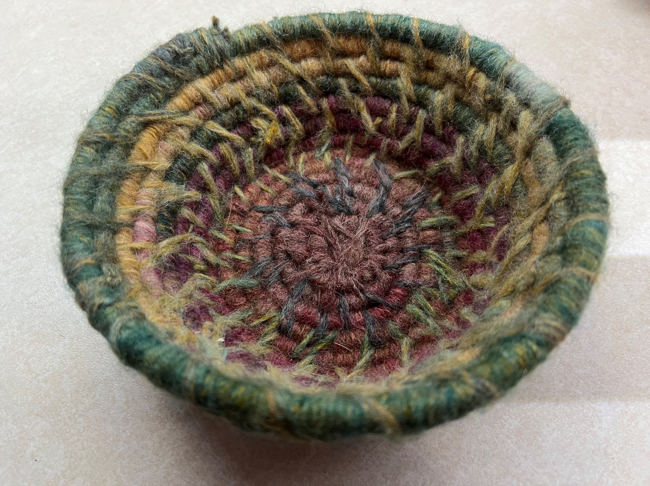

Image description: This is a round basket that looks like a bowl. The color varies from row to row and includes all the colors of the rainbow. I created the basket using a packed paper used in basketry as the base. The paper feels like a tuff cord that is 3/8th of an inch in thickness. I chose a variegated yarn that is almost a rainbow color that was wrapped around the paper. Once the paper was completely wrapped, I started coiling and sewing it to form a basket.
Loom-Knitted Hats
Designed by Jessica Dale

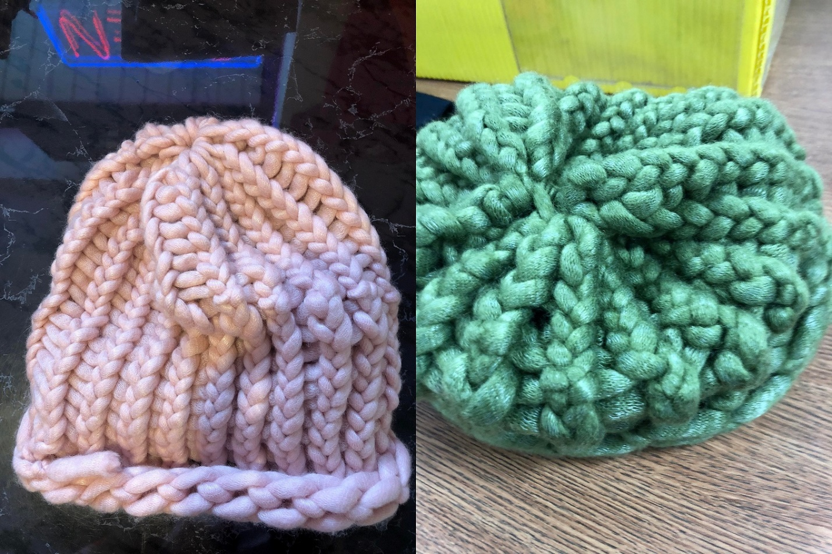

Image description: On the left is a pink hat, and a green one on the right. I made them by hand with a round loom. I used Yarn B worsted weight yarn. To make looming easier for me, I choose to use my fingers instead of the tool that is normally used in loom knitting. I also choose to work with thicker yarns to reduce the chances of splitting or yarn breakage. I am happy to answer any questions anyone may have and can be found in the ACB Next Gen Lounge.
Shot in the Dark Socks
Designed by MOe Carpenter

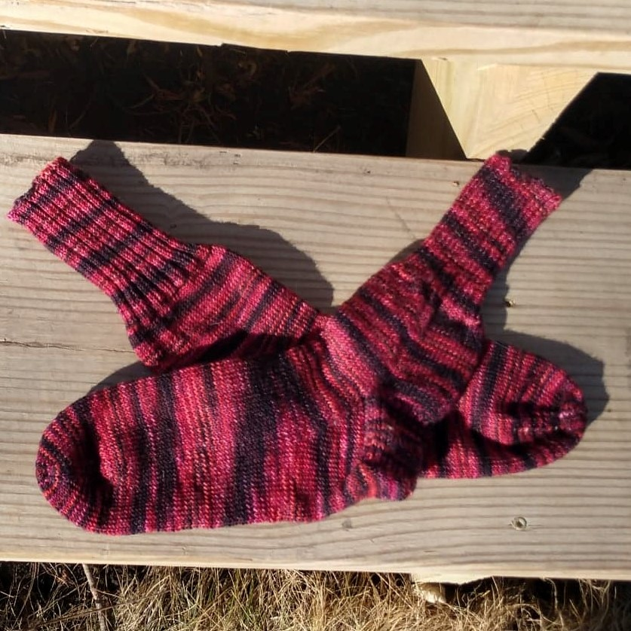

Image description: These variegated red hand-knitted socks are crisscrossed on a set of wooden stairs. This pair of socks was for my husband. They are made from a 75% Marino, 25% nylon blend of yarn. The yarn is hand-dyed by Leading Men Fiber Arts and is in the color Shot in the Dark. This coloring features very deep moody reds. As my husband likes his socks long, these use at least 80 grams of fingering weight yarn, which is about 370 yards. I have moved to doing socks with a 2-millimeter knitting needle.
Making handknit socks has become my go-to craft over the past couple of years, and I couldn’t even knit until 2018. I find the lack of vision to not be a concern in such projects except for row counting, and my husband has 3d-printed me a handy little tool to use to count my rows. I love crafting for practical uses, and it makes my husband so happy to get a custom pair of OOAK (one-of-a-kind) socks just for him.

For my knitting crafty friends, these are again made with a 2-millimeter, 9-inch circular needle. They are a basic cuff down vanilla sock. The heel turn will take a little more explanation, but I’m happy to walk you through it if you ask. I use a 3-by-2 rib for 56 rows, stockinet for 35, work heel, and then 56 more rows of stockinet, before working the toe. I chose the rib and the foot to be the same to make it easier to remember, so all the other socks I make are reflective of this.

Knitting is a craft I picked up in my current visual status. Don’t be afraid to try it. It took me at least three serious attempts, and I was a lifelong crochet artist before I ever tried knitting. You don’t need sight to make things for everyday use.

***

Book Review
Wicked Rebellion
Wicked Kingdom, Book 1
by Daisy Russell

Genres: Young Adult, Dark Fantasy
Themes of injustice, oppression, and violence.
Dark secrets brought to light and terrible acts driven by fear and hatred ignite a bloody war within the shadows just beyond this world. The Hell Realm is a beautiful and terrible place ravaged by centuries of chaos. Starving and abused creatures’ riot against their unjust king. An attempt to bring about peace ends in a tragic sacrifice. Mad with grief, the king locks the gates to the Hell Realm and hides away the key.

Almost eighteen years later, the gates are accidentally left open, unleashing the hungry Hell creatures on the world. Sabrina, better known as Brina, knew nothing about the Hell Realm and her role as its princess until a nap in the cemetery triggers the beginning of a prophecy made years ago. It hints that she may be the change the Hell Realm was looking to come. Brina is a fragile, haunted teenager, or so the outsiders think, until she's confronted with the monsters hiding in the shadows. With her father missing, Brina is left to be protected by her sarcastic, tough love giving best friend, Jayson. The two are joined by Jayson's older brother and the object of her hopeless crush. The three are forced to run for their lives and fight off creatures that want to kill Brina or use her to win the war that has been waging on for centuries. After learning painful truths about herself and the ancestors that came before, Brina has to make a decision. Will she follow in her father's footsteps and allow hatred and fear to guide her, or will she change the Hell Realm for the better and bring the creatures that call it home the justice they deserve?

Available in eBook and paperback from Amazon: https://www.amazon.com/dp/1736516949?ref_=pe_3052080_397514860

Please follow www.facebook.com/daisywriting for more updates.

***

The ABCs of Financial Health
By Christopher Peterson
Founder, President, and CEO, Penny Forward

Introduction
Does money stress you out? If it does, you’re in good company because 64 percent of adults report that money is a significant stressor in their lives. That number goes up to 73 percent for people with lower incomes. Chronic stress can lead to other health issues, which can lead to more stress, so it’s critical that we act now to tackle our financial health issues before they bleed over into other aspects of our lives. In this article, you’ll learn how wisely using your assets, budget, and credit can improve your health by helping you confidently make financial decisions.

Assets
Do you remember when you bought something for the first time with your own money? When I was in first grade, I got $20 from my grandparents for my birthday. At the time, that was more money than I’d ever had before, and I knew exactly what I wanted to do with it. I wanted a tent I could set up in the backyard so I could go camping. I don’t remember how I knew that I could buy a two-person tent for $20, but I had $20, I wanted a tent, and I was convinced that I could afford it.

At first, my parents were very supportive and took me to store after store looking for a tent, but as time wore on and we still hadn’t found the right tent in my price range, they started pointing out other things I could use my money for. I could, for example, buy a sleeping bag for $17, or a campfire cooking set for $10. I was getting frustrated, so I almost relented and bought something else, but they could tell that wasn’t really what I wanted, so they encouraged me to be patient. I’d either find a tent in my price range, or I’d find a way to make more money to buy what I wanted. They turned out to be right and I did end up finding a tent for exactly $20. I set that tent up every summer well into my high school years, so I got a lot of enjoyment out of spending that money. Would I have enjoyed a sleeping bag or a campfire cooking set as much without the tent I really wanted?

Probably not.

The things we own–financial professionals call them assets–can bring us a lot of enjoyment, but they can also help us to learn new skills, improve the skills we have, and earn more money. Buying things that help us to do one or more of these things is called investing. Whenever you buy something, I encourage you to ask yourself the following questions:
- How will buying this make me feel today?
- How will buying this make me feel a month from now?
- How will buying this make me feel a year from now?

Regularly having that conversation with yourself–or even out loud with your family and friends–will help you to focus on buying things that will improve your future life.

Budget
A budget is simply a list of prices you’re willing–and able–to pay for things you need or want. My first-grade self had a budget of $20 for my tent. I did not, however, have a sleeping bag or campfire cooking set in my budget at the time, so my parents were right to encourage me to stick to my budget and only spend my money on my tent.

As adults, our budgets are far more complicated, but still rely on the same principle I learned when I was in first grade. Only spend what you have, and only buy the things that are in your budget.

When I moved out of my parents’ home, I rented a room from a close friend to keep my housing costs down. I was lucky because my friend’s house was in easy walking and bussing distance from work, which reduced my costs even further. Living with roommates or living close to work or places you go regularly are a few ways you can keep your housing and transportation costs under control.

I encourage you to at least divide your budget into the following three categories.

Investing Money
Investing money is money we use to buy assets that will improve our future lives. Your investments may be things you can touch, such as musical instruments, if you can earn money playing music, computers if you can earn money online, or stocks, bonds, or mutual funds that can help you to earn money simply by owning them. If we start when we’re young, it’s safe for this to be the smallest part of our budget. If we put off investing until we’re older, though, or until we’re making more money, we’ll need to spend a lot more on our investments to get the same result.

Living Money
Living money is money you spend on things you need to live, such as housing, utilities, and groceries. This is the largest part of our budget, for most of us, but we can keep it under control by being patient and persistent.

By taking the time to take advantage of government programs, regular sales, and coupons, you’ll be able to keep your living expenses under control, leaving room in your budget for investing and fun.

Fun Money
Fun is an important part of our lives. It reduces stress hormones and helps us to build emotional strength. I encourage you to have fun in financially, physically, and emotionally healthy ways. Cooking and eating with friends at home, for example, can be far less expensive–and healthier–than getting together at a restaurant. Similarly, exploring a part of your hometown that you hardly ever visit can be as much fun as, but much cheaper than, traveling to another state or country.

Setting aside a separate amount for fun money will help you to focus on healthy and relaxing activities now and you’ll be glad you did it in the future.

Credit
When I was looking for my $20 tent, I was easily able to find many more expensive tents. My parents encouraged me to wait until I found the right tent at the right price. I could’ve also borrowed money from them to buy a more expensive tent and paid it back later. That might’ve been tempting if they had let me know that that was an option at the time, but fortunately, my parents didn’t offer to loan me money until much later in my life. Had I borrowed money from my parents, I might’ve sacrificed future Christmas and birthday money to pay them back. Would I, as a second grader, have enjoyed sacrificing my next birthday present to pay my parents back for my last Christmas present?

I don’t think so.

Whenever we use a credit card or take out a loan to buy something, we’re sacrificing money we might have tomorrow to pay for something today. There are many times when we may not want to make that sacrifice, but there are other times when we might.

When I started college, I felt that having a reliable laptop computer would be very helpful, but I knew that I didn’t have enough cash to pay for it all at once.

I did, however, know how much I could afford to pay monthly so I could have my laptop when my classes started, and that helped me to figure out how much I could afford to borrow. Without realizing it, I’d set a budget for my laptop. That limited the brand and options I could afford, so I didn’t get exactly what I wanted, but I was able to comfortably pay it off without excessive stress, and I was able to take it from class to class for all four years of my college career.

The most important part of using credit is knowing that you’re going to be able to pay the bill on time every time. After you’ve asked the questions I proposed above, I encourage you to ask yourself these additional questions to decide whether to use credit:
- How much will I pay per month?
- How long will it take to pay it off?
- How will I feel about my purchase when it’s paid off?

These questions will help you to focus on using credit, when you can afford it, to buy things that will improve your future life.

Conclusion
Money will always be a significant stressor, but by forming good habits and making good decisions now, we can reduce the stress we feel in the future, beginning with buying assets that will help us improve our future lives, setting and sticking to a simple budget, and using credit wisely so we can make our payments on time, every time.

If this feels easier said than done, then Penny Forward may be able to help. We offer an innovative online financial learning platform that can help you learn to make healthy financial decisions, group discussions with your fellow students and instructors to help you practice what you’re learning, and access to one-to-one coaching when you need extra help. Visit pennyforward.com/membership to learn more and sign-up.

***

Calendar of Events
Everyone is welcome to attend these events by accessing the Zoom mobile app, visiting the Zoom website at https://zoom.us, or calling (312) 626-6799, and entering the appropriate meeting ID and passcode.

You may sign-up to receive reminders and Zoom details by subscribing to the ACB Next Generation email list. Please send a blank email to main+subscribe@acbnextgeneration.groups.io

In addition, many ACB Next Generation events are listed on the ACB Community Call schedule.

(This list does not include convention events, please see the convention article on page 6)

April
19 - Fireside Chat / Monthly Education Program (About Brenda Dillon and the Brenda Dillon Walk) – 8pm ET
23 - Saturday Night Live Hangout (Get Up and Get Moving) - 7pm ET

May
5 - Fireside Chat – 9pm ET
9 - ACB Next Generation Board Meeting - 8:00 PM ET
17 - Monthly Education Program – 8pm ET
28 - Saturday Night Live Hangout (Voting Task Force) – 7pm ET

June
2 - Fireside Chat – 9pm ET
6 - ACB Next Generation Special Mid-Year Membership Meeting – 8pm ET
13 - ACB Next Generation Board Meeting – 8pm ET
21 - Monthly Education Program – 8pm ET
25 - Saturday Night Live Hangout (Convention Pep Rally) - 6:30pm ET

July
1-8 - ACB Conference and Convention
15 - July NextGen Insight published
***

ACB Next Generation Board of Directors
President – Amanda Selm
1st Vice President - Matt Selm
2nd Vice President – Melanie Sinohui
Secretary - Greg Lindberg
Treasurer - Maria Kristic

Director - Shane Aguilera
Director - MOe Carpenter
Director - Kristen Kelling
Director - Onkar Nerurkar
Director - Cassie Trosper

***

How to Reach Us
Email Address: ACBNextGen@gmail.com
Phone Number: (202) 524-0909
Website: http://www.acbnextgeneration.org
Social Media:
http://www.acbnextgeneration.org/contact-us
ACB NextGen Blog: http://www.acbnextgeneration.org/blog

The NextGen Insight is published four times a year:
(January 15, April 15, July 15, and October 15) in digital form via email and posted to our website the following month. Send contributions to ACBNGNews@gmail.com

