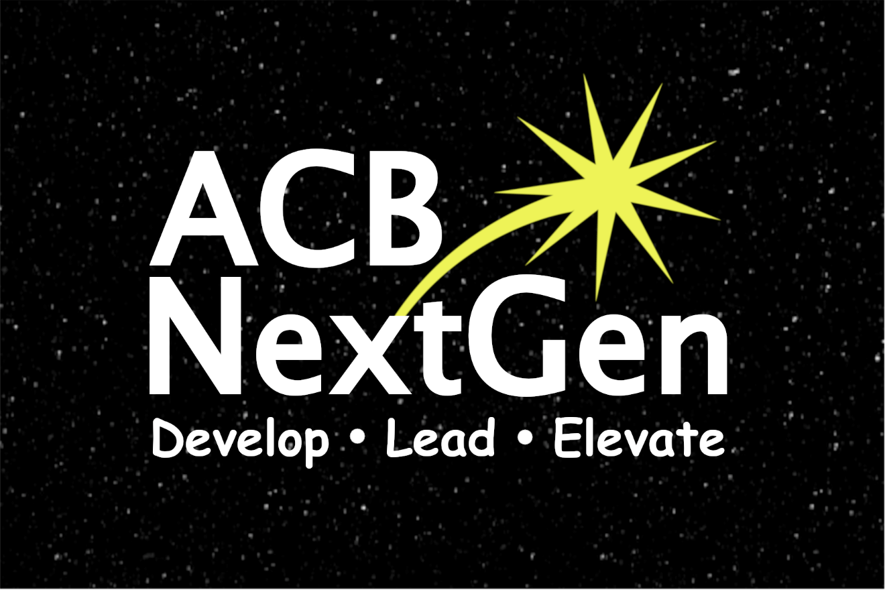

NextGen Insight

Volume 2, Issue 3
July 2022

Publications Committee Chair: Greg Lindberg

Table of Contents

President’s Message 1
Fundraising Committee Update 5
Cooking Up Something Tasty for the Fall 6
2022 ACB NextGen Award Winners 7
2022 ACB Conference and Convention Highlights 10
Self-Week Social Discovery Experience 16
Calendar of Events 19
ACB Next Generation Board of Directors 21
How to Reach Us 21

***
Title Page Image Description: Background - Black night sky with dim stars in a horizontal rectangle. Foreground - All text is in white font. NextGen spans the width of the image with the N and G capitalized. ACB is in capital letters above the word Next. A yellow star is shooting out of the top right corner of the letter x and hovering over the word Gen. Underneath and spanning the width of the word NextGen are the words Develop Lead Elevate (1/3 of the font size of ACB NextGen) with a dot between each word.
““A moment’s insight is sometimes worth a life’s experience.” – Oliver Wendell Holmes, Jr.
***

President’s Message

Dear ACB Next Generation Family,
As always, I am so thrilled to share my heart with you and get you excited about what’s been happening in our affiliate. If you asked for a summer of excitement, you got it!

Let’s start by celebrating our latest achievements, and then I’ll share some news about what’s coming up in the next couple of months.

Oh my goodness! Wasn’t that an awesome ACB Convention? I am extremely thankful that ACB was able to create a hybrid format for this year’s Convention. Based on your feedback, I believe everyone enjoyed themselves, whether they attended in person in Omaha or virtually. I enjoyed seeing your posts in our ACB Next Generation Lounge and seeing your photos all over social media.
I am extremely proud of our Convention Committee for putting together outstanding programs for the 2022 ACB Conference and Convention. This year, our Convention Committee consisted of Melanie Sinohui and Cassie Trosper, our Convention Committee co-chairs, along with Gregg Wandsneider, Kristen Kelling, and Shane Aguilera. There were so many awesome programs this year, and we had great turnouts in person and virtually at each and every one of them. We also partnered with some amazing affiliates and committees. A huge thank you to Friends in Art (FIA), ACB Students, ACB’s Employment Committee, Independent Visually Impaired Entrepreneurs (IVIE), Council of Citizens with Low Vision International (CCLVI), ACB’s Get Up and Get Moving Campaign (GUGM), and the Alliance on Aging and Vision Loss (AAVL) for their outstanding partnerships and contributions. My hope is that if you have not been bitten by the Convention bug yet, you catch it soon. Make plans now to join us for the 2023 ACB Conference and Convention in Schaumburg/Chicago next year. The dates that were announced previously are June 30 through July 6, 2023.

It has been a privilege once again to lead our ACB Next Generation Allstars Walk Team to victory. We placed fourth among the top five teams for the ACB Conference and Convention deadline. Because of your generosity and sharing your NextGen stories, we have currently raised $2,700.33. Fifty percent of what we raise will come back to our affiliate, and the other 50% will go to ACB. Let’s give a huge round of applause to everyone who has joined our team: Amanda Selm, Matt Selm, Melanie Sinohui, Shane Aguilera, Cassie Trosper, Abi Trosper, Amber Steet, Gregg Wandsneider, Greg Lindberg, Kristen Kelling, TerriLynn Higashi-Akamine, Michael Babcock, Lillian Goodman, Jordan Mirander, MOe Carpenter, Randy Reed, Amber Grant, and Nickie Coby. We currently have 18 people on our team, and our goal is 20. Let’s give one more round of applause for our donors: Donna Brown, Kenneth Semien Sr., Joshua Taylor, and our Anonymous Donors. Our goal is $4,000, and we can accept donations up until August 31. Way to Go ,Allstars! Here’s the link if you would like to join our team, make a donation, or to share with your family and friends.
https://secure.qgiv.com/event/a2w/team/897607/

Congratulations once again to Gregg Wandsneider who was the recipient from the East for the DKM First Timers Award and to Kristen Kelling who was one of five recipients of the ACB and JP Morgan/Chase Leadership Fellow Award. I am extremely proud of both of these individuals. It was an absolute pleasure to submit letters of support on their behalf. I am looking forward to seeing them step up even further into leadership.

Mark your calendars and make plans now to join us for our Committee Showcase. This event will be split up into two parts once again this year. Part 1 will take place on Thursday, August 4, and Part 2 will be held a week later on Thursday, August 11. Following each session, there will be a Committee Interest Form for people to fill out to share which committees they are interested in being a part of next year. The deadline for those submissions will be August 25. Afterward, the submissions will be sent to the Committee Chairs. I then begin working with the Committee Chairs to prepare for the upcoming year.

Do you like to bake yummy treats or enjoy getting creative? Are you looking for another way to give back to ACB? If your answer is “yes,” I would like to invite you to join our affiliate in donating an item for the ACB Holiday Auction where all proceeds go to ACB Media. The ACB Auction Committee will begin taking donations in September. The deadline to submit your description and photo for an auction item is October 17. For questions or to make a donation, please contact Leslie Spoone via email at, lesliespoone@cfl.rr.com.

As you can see, there are so many wonderful things happening inside and outside of our affiliate. Please be sure to stay connected with us. In closing, I would like to leave you with this inspiring quote about kindness: “No act of Kindness, no matter how small, is ever wasted.” Aesop
Have a great summer, everyone!
Sincerely,
Amanda Selm
President, ACB Next Generation

***

Fundraising Committee Update
By Moe Carpenter

We’re in the middle of summer, and I’m happy to report that things are going along great on the ACB Next Generation fundraising front. We are almost at 88% of the way to bringing in what we had hoped for 2022. This is to keep ACB NextGen programs and activities at their current levels, but of course we would love to grow. This includes Brenda Dillon Memorial Walk funds that are not yet in. The donations for the walk do not close until the end of Aug, and as I write this, we still have $100 to go to just meet our budget goal. We have about $1,300 to go to meet our growth goal. To get another $100, it only takes four more team members to come and join us. So, please do consider joining our team and getting your chance to win one of three $25 gift cards we are giving away to our walkers. I will include the link at the end of this article. In addition, we held the Double Good Popcorn fundraiser to provide your convention snacks, and we smashed our goal, bringing in $763. This helps us fund our Zoom account for another year and registration assistance for both the D.C. Leadership Meetings and ACB Conference and Convention next year.
Finally, we have a few exciting events coming up this fall. Keep reading for more information about the ACB Next Generation 2022 Cookbook.

Once again, our walk page is at https://secure.qgiv.com/event/a2w/team/897607/.
***

Cooking Up Something Tasty for the Fall
By Moe Carpenter

There’s something brewing in the ACB Next Generation Fundraising Committee. We are currently editing over 101 recipes that will be released this Oct in the first-ever ACB Next Generation Cookbook. This will include several recipes that are catered to less traditional diets, and of course many family favorites. Specific details haven’t been set yet, but we are planning to make this publication a fully accessible digital file. If you have any questions or would like to submit a recipe, please email the fundraising committee at: fundraising@acbnextgeneration.org.
***

2022 ACB NextGen Award Winners

Congratulations to two of our highly engaged members of ACB Next Generation on taking home two prestigious awards during this year’s ACB Conference and Convention. Thanks to information compiled by the DKM Committee, read more about them and their accomplishments below.
Caption: Gregg Wandsneider speaking on stage during the opening session of the 2022 ACB Conference and Convention in Omaha, NE

Gregg Wandsneider resides in Waukesha, WI. He is the 2022 DKM First-Timer from the East. He is an active and committed member of ACB Next Generation and currently serves as chair of the Public Relations/eCommunications Committee, along with service on the Convention Committee. Gregg has shared his abilities with the Programs Committee and remains an encourager to affiliate members. As a member of ACB Students, Gregg sits on the board of directors and utilizes his professional background in communication and strength of working well with others to be an asset.

As a full-time student, Gregg is pursuing an associate degree in studying the Bible from Ethnos 360 Bible Institute of Waukesha, WI. His volunteer work includes teaching elementary-aged children at his local church. Gregg has a bachelor’s degree in communication from Carroll University in Waukesha and serves on the Carroll University Alumni Council.

Gregg feels empowered to serve within the ACB Community as a trained Zoom meetings and webinar host, as well as having the privilege of meeting other ACB members while serving as a community meeting facilitator.
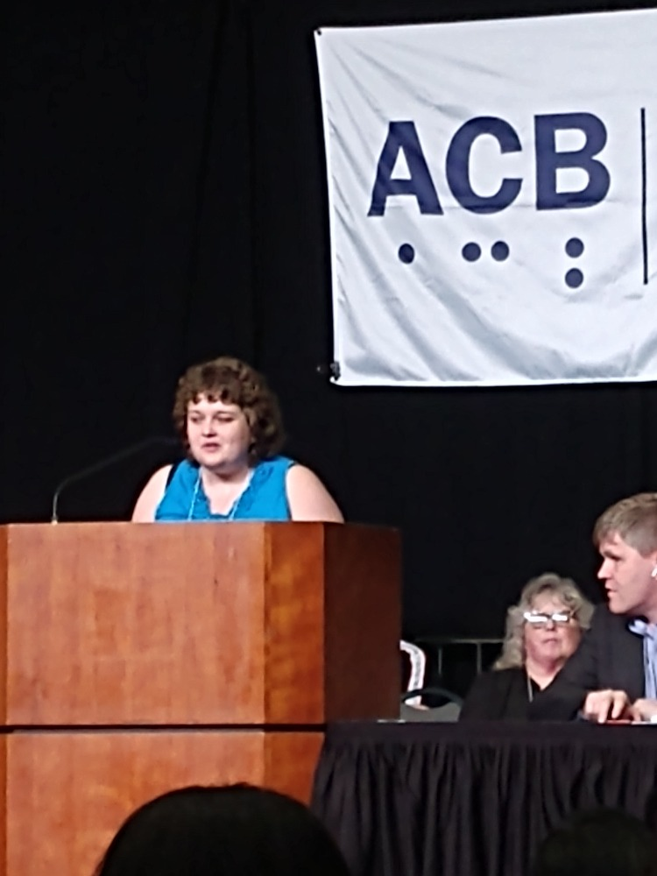
Caption: Kristen Kelling speaking on stage during the opening session of the 2022 ACB Conference and Convention in Omaha, NE
Kristen Kelling is a 2022 ACB/JP Morgan Chase Leadership Fellow. She serves as the secretary of the Michigan Council of the Blind and Visually Impaired (MCBVI) and chair of the Affiliate Membership Committee. She serves as membership Chair of her local chapter as well. Kristen holds membership in ACB Next Generation and appreciates sharing her personal knowledge and experience to ensure that she is a contributing member of the board of directors. Her committee service extends to convention, Membership and co-chair of the Programs Committee. Kristen is known to be a team player, extremely attentive, understanding, and dependable. She is also a terrific zoom host and serves both the ACB Next Generation affiliate and the ACB Community well.
Kristen obtained her bachelor’s degree in social work from Grand Valley State University. She has volunteered with Disability Advocates as a receptionist and then with the advocacy department where she enhanced her ability to advocate more effectively.

Kristen delightedly serves as president of her local Lions Club; as a youth leader at her church, and as chair of the Consumer Advisory Committee for Seniors and Individuals with Disabilities, which is the advisory committee for the local transportation authority. She is eager to identify areas in which she can serve best.

***

2022 ACB Conference and Convention Highlights
We caught up with several ACB Next Generation members to garner their feedback on attending the 2022 ACB Conference and Convention. Some attended in person in Omaha, while others were virtual attendees. Melanie Sinohui also captured a few photos from some of the in-person events.
“I attended the 2022 ACB Conference and Convention in person thanks to a scholarship as a DKM First Timer. My scholarship basically covered all of the expenses of attending the convention. I’d like to thank Amanda Selm for giving me the opportunity to apply for this award.
I think what was so cool is that I’ve met so many people on Zoom over the past two years, and I hadn’t met any of them in person. They were really cool to meet in person. I really, really enjoyed this. I also enjoyed learning more about ACB and how it does business.
One other thing that was really cool is how independent I was able to be. I took escalators for the first time by myself, and I’ve always been terrified of escalators. The convention also helped me get over one of my other fears, a fear of dogs. I’m not totally over it, but I met several guide dogs at the convention, and I even got to pet Cindy Hollis’ dog.
Overall, it was great getting to know so many people, and the sessions I attended were really interesting. I especially liked the sessions on diversity, equity, and inclusion and also turning safe spaces into brave spaces. I even got some freebies in the exhibit hall like a toy shark. I have to say it was such a positive experience at convention.” – Gregg “Triple G” Wandsneider
“I really enjoyed the 2022 American Council of the Blind convention. While I was virtual, I do hope to be there in person next year. I really enjoyed the Friends in Art (FIA) Showcase and seeing a lot of our Next Generation family perform there. That was a really great event.
I also enjoyed the Art of Disability presentation where all of the artists spoke. It was very interesting to hear their perspectives as an artist, whether they paint, sculpt, etc. and what it was like for them submitting their work in galleries and how they overcame a lot of challenges when visiting galleries to look at other artists’ work.
I also really enjoyed all of the general sessions, and I loved getting to have my voice heard during the election. I loved all of the events put on by Next Generation, especially the meet-the-family event. The pep rally before convention was awesome too. I loved getting to partake in all of the after-hour socials.
I think the most inspiring part of the convention for me was the induction ceremony for the DKM First Timers and the JP Morgan Chase Leadership Fellow Award winners. It was awesome hearing several Next Generation family members get inducted, and it was really inspiring to me to see this. Hearing the ceremonies for these awards really motivates me to want to serve. Thank you, American Council of the Blind, for putting on such an amazing convention. It was definitely one of the best yet.” – Amber Grant

“I was only able to attend the convention virtually this year, although my close proximity allowed me to meet up with convention friends to lunch a few times. It was so great to get to break bread with these few, but of course it was not near enough time with them. I also got to help set up some behind-the-scenes things for different groups. I was able to facilitate an event for NextGen, helped present for ACB Families, and hosted for the Community hospitality room.
It would have been helpful if my area hadn’t had Internet outage issues, but we made it through as best we could. Luckily, the ACB Media line to listen to events came in handy those days. Even if I was not able to participate on Zoom, I could listen in. The ACB Media line also allowed me to be on the road going to Fourth of July events so I could be with family and ACB at the same time. If you go to my page on Facebook, you can see me with one of my ‘littles’ waiting for the parade to start while I’m also listening to election results from the convention! All in all, I’m so happy to have gotten to be a virtual participant, but I hope I can attend in person next year.” – Moe Carpenter
“The 2022 ACB Conference and Convention was my fourth and first in-person convention since 2016. As a 2021 JP Morgan Chase Leadership Fellow, I was truly honored to be recognized during the opening session on Saturday evening at the hotel. I also found the Leadership Fellows reception to be quite beneficial as we got to chat with each other in a more informal setting but also shared some valuable leadership experiences and goals.
The ‘selling yourself’ session co-sponsored by ACB Next Generation was very memorable. I thought the three panelists provided some fantastic insight into the interviewing process, landing a job as a blind or visually impaired candidate, and some valuable tips and tricks like having a friend help a candidate make sure they are lined up on Zoom for an interview. In addition, the Berl Colley Leadership Institute events provided a wealth of ideas on how to be an effective leader and creating both safe and brave spaces.

Along with the sessions, I had the chance to go on the Mormon Trail and Lewis and Clark tours. I was highly impressed with how accessible these tours were, especially since I didn’t get a chance to do any at my first convention. The staff at both venues provided everything from an audio-described documentary to tactile artifacts we could touch. As a history buff, these tours really added a unique flavor to my convention experience.
Finally, I enjoyed the Q&A-style discussion with Judy Human, the banquet speaker. I know how much she has done in her life for the disability rights movement, and I can’t wait to read her book. I also highly recommend the documentary Crip Camp featuring she and many others in this movement.” – Greg Lindberg

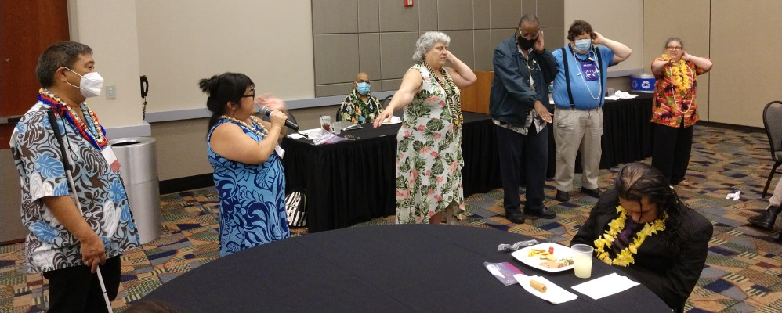
Caption: Anthony Akamine and TerriLynn Higashi teach Cindy Hollis, Michael Garrett, Gregg Wandsneider, and Donna Browning to hula during the DKM Reception

Caption: Nikki Colby and Eric Malcolm participate in yoga during the Self Care is Health Care program at the 2022 ACB Conference and Convention in Omaha, NE
***

Self-Week Social Discovery Experience
By Moe Carpenter

This past May, I participated in the Self-Week Discovery program through the Iowa Department for the Blind (IDB). Being the housekeeper for a family of six, I have four children, and we have four fur babies. So, needless to say, I don’t get much time away from the family. In fact, since I started my family about 16 years ago, my focus has basically been on keeping things afloat for the family. I cannot think of anytime during those past 16 years when I have been away from the busy household for more than an overnight stay, and then it’s pretty much being around other family. Never have I been truly on my own, let alone for an entire week!

The self-week program was started in just the last few years. It is basically a week of IDB training in which you work on travel/O&M (orientation and Mobility,), Braille, technology, and home management each weekday. There is also some time for a few after-hours outings, and meals are basically held with the full group of self-week participants. The weekend days are basically for moving in and back out again.

All of this was fine. However, I am not a fan of the forced sleep shade experience, or as IDB refers to it as “the structured discovery,” but I survived. In fact, as much as they try, I am probably even firmer on my stance that I will never be able to learn fully what I need to learn while wearing sleep shades because I already do so much with non-visual techniques, and the sleep shades take so much of that away for me. However, I did learn something about myself during this experience. I rediscovered my social abilities while attending self-week. This is not something I had anticipated, and it really surprised me that this stood out so much for me during the training or, rather, around the structured training. During meal times and after hours, I spent a lot of time getting to know our small group better. I found out that I am much more than just a mom to four boys trying to make it day to day, but rather a pretty social person who enjoys watching others progress in their blindness skills. I realized that I am also a person who does not like to be alone. Being alone in a room that had just the necessities to get by is not something I will be looking forward to when going back for more of this training. However, the late-night outings we had with just this group, a group of strangers to me for the most part, was truly the highlight of my entire time there. I really excel in an environment away from home where I am forced to not stand behind someone else but rather stand on my own. So, in that roundabout way, I did get the confidence boost the self-week is designed for, but probably in the exact opposite way as it was the after-hours events where I really felt I excelled.

As far as sleep-shaded structured discovery, I do understand it is probably needed for some, if not most, blind people. However, I think for those who have been visually impaired their whole lives, we have learned to adapt over time and don’t really rely on non-usable vision. As such, we should have another option for skills training in this state.
In the end, I am so glad I got that week away from my family, the stressors of running it, and finding out they could all survive without me for a bit. Guide Dog school in my future?

***

Calendar of Events
Everyone is welcome to attend these events by accessing the Zoom mobile app, visiting the Zoom website at https://zoom.us, or calling (312) 626-6799, and entering the appropriate meeting ID and passcode.

You may sign-up to receive reminders and Zoom details by subscribing to the ACB Next Generation email list. Please send a blank email to main+subscribe@acbnextgeneration.groups.io

In addition, many ACB Next Generation events are listed on the ACB Community Call schedule.

July
23 - Saturday Night Live Hangout (ACB Convention Deliberations with Friends + $500 Grand Prize Drawing) - 7pm ET

August
4 – Committee Showcase, Part 1 – 9:00 PM ET
8 - ACB Next Generation Board Meeting - 8:00 PM ET
11 – Committee Showcase, Part 2 – 9:00 PM ET
16 - Monthly Education Program – 8pm ET
27 - Saturday Night Live Hangout – 7pm ET

September
12 - ACB Next Generation Board Meeting – 8pm ET
20 - Monthly Education Program – 8pm ET
24 - Saturday Night Live Hangout - 7:00pm ET

October
10 – ACB Next Generation Board Meeting – 8:00 PM ET
15 - October NextGen Insight published and White Cane Safety Day
18 – Education Program – 8:00 PM ET
22 – Saturday Night Live Hangout – 7:00 PM ET
***

ACB Next Generation Board of Directors
President – Amanda Selm
1st Vice President - Matt Selm
2nd Vice President – Melanie Sinohui
Secretary - Greg Lindberg
Treasurer - Maria Kristic

Director - Shane Aguilera
Director - MOe Carpenter
Director - Kristen Kelling
Director - Onkar Nerurkar
Director - Cassie Trosper

***

How to Reach Us
Email Address: ACBNextGen@gmail.com
Phone Number: (202) 524-0909
Website: http://www.acbnextgeneration.org
Social Media:
http://www.acbnextgeneration.org/contact-us
ACB NextGen Blog: http://www.acbnextgeneration.org/blog

The NextGen Insight is published four times a year:
(January 15, April 15, July 15, and October 15) in digital form via email and posted to our website the following month. Send contributions to ACBNGNews@gmail.com

