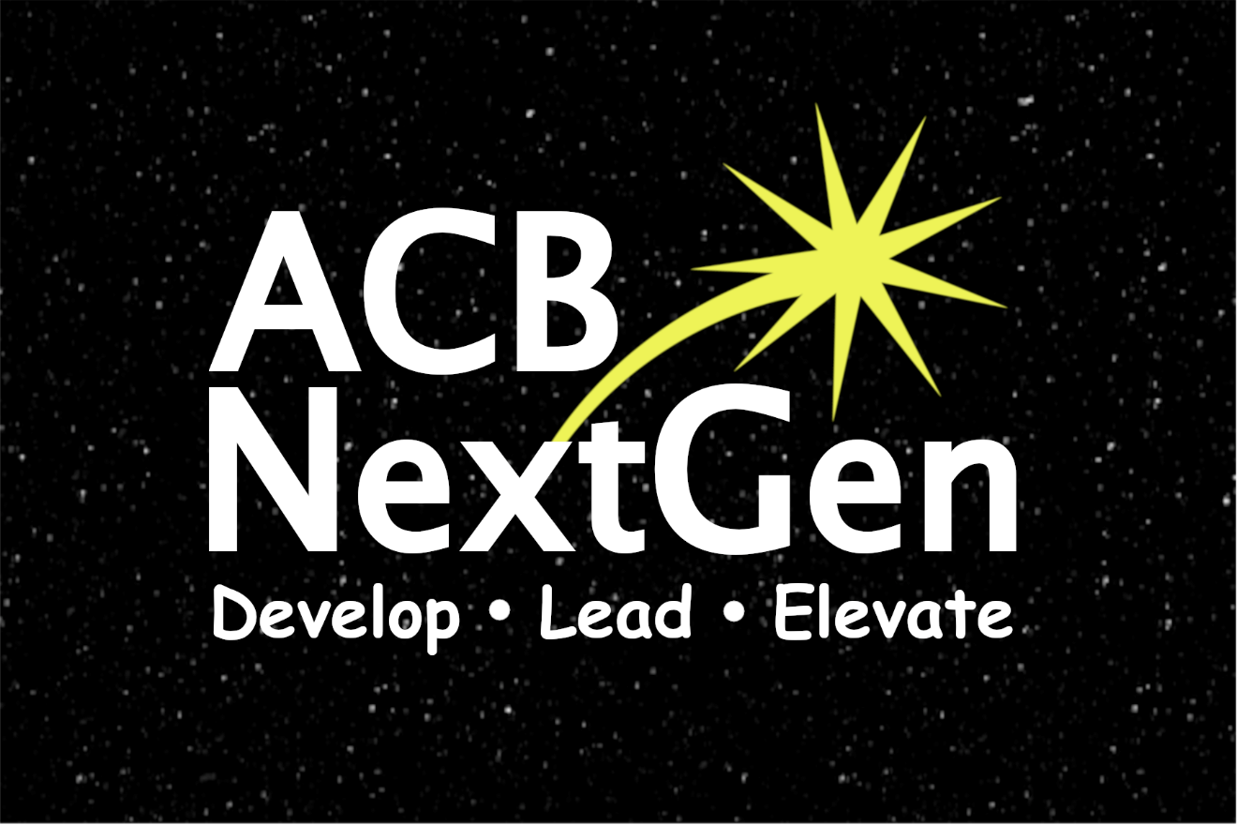

NextGen Insight

Volume 3, Issue 3
July 2023

Publications Committee Chair: Greg Lindberg

Table of Contents
President’s Message 1
2023 ACB/JPMorgan Chase Leadership Fellows in ACB NextGen 4
2023 ACB Conference and Convention Member Feedback 9
A Photographic Glimpse into ACB NextGen at the 2023 ACB Conference and Convention 13
ACB NextGen Convention Door Prize and Swag Bag Donors 19
Fundraising Update 22
KCB Next Generation Update 24
NextGen101 Roles Out the Red Carpet 25
You’re Invited: 2023 Committee Showcases 26
Tech Tip: Eleven Labs 27
ACB Next Generation’s Maria Kristic wins Writing Award at ACB Conference and Convention 29
Calendar of Events 37
ACB Next Generation Board of Directors 39
How to Reach Us 39

***
Title Page Image Description: Background - Black night sky with dim stars in a horizontal rectangle. Foreground - All text is in white font. NextGen spans the width of the image with the N and G capitalized. ACB is in capital letters above the word Next. A yellow star is shooting out of the top right corner of the letter x and hovering over the word Gen. Underneath and spanning the width of the word NextGen are the words Develop Lead Elevate (1/3 of the font size of ACB NextGen) with a dot between each word.

“If one is master of one thing and understands one thing well, one has at the same time, insight into and understanding of many things.”
– Vincent van Gogh

***

President’s Message
Dear ACB Next Generation family,
Happy Summer! Things are heating up in our affiliate. We just returned from the 2023 American Council of the Blind Conference and Convention. We had several people join our affiliate for the very first time, and we have so much to look forward to during the next few months.
I would like to thank our entire Convention Committee for their outstanding work. Our programming just keeps getting better and better each year. I can’t wait to see what our convention crew puts together for next year. Thank you to Melanie Sinohui, Cassie Trosper, DJ McIntyre, TerriLynn Higashi Akamine, Gregg Wandsneider, and Hindley Williams for putting together all of our NextGen programming. I would especially like to thank Brynn Lee for her assistance with our pep rally, as well as all of our other outstanding panelists and the affiliates we partnered with for this year’s ACB Conference and Convention. I say this every year: Start making your plans now to join us next year. We will be in Jacksonville, FL from July 5 through July 12.

I enjoyed meeting several of our amazing NextGen members. I was sad that I had to leave early, and, in some cases, I don’t think I spent enough time with some of you. It was so nice to see you and hear your voices in real life. I hope to see you all again next year and spend more time connecting.

Who’s ready to grow our affiliate? During the three-week convention timeframe, we had a total of 31 people join and/or renew for 2024. Twenty-four of those individuals were returning members, and seven were brand new members. Congratulations, NextGen! We just earned our first affiliate vote for next year’s convention. Thirty-one people paid their dues in a three-week timeframe. Let this sink in for a second. Beginning September 1, you can pay your dues for 2024. Let’s make it our goal to have 125 members by next spring. The ACB Conference and Convention gave us a running start, bringing our new total down to 94 members. This would include current members renewing and brand new members. You can help by telling your friends about our affiliate and bringing friends to our events. If you are not sure whether your dues are up to date, please reach out to membership@acbnextgeneration.org.

Are you interested in getting more involved in NextGen? Make plans now to join us for our annual Committee Showcases. Part 1 will be held on August 1 and Part 2 on August 8. Following the Committee Showcases, a committee interest form will be sent out. Once the deadline closes, submissions will be distributed to the appropriate Committee Chairs who will then reach out to prospective members to setup a time to talk with you about the Committees you expressed interest in being a part of next year.

I always enjoy concluding my President’s Messages with some gratitude. I’m thankful for the work of our Board of Directors, our amazing Committee Chairs and NextGen Committees, and our members. While in Schaumburg, I was reminded of why we started this affiliate – because our younger members, and the future generation of ACB, need a place to call home. I am grateful to have had the opportunity to watch this organization transform from a small ACB committee into one of the best special interest affiliates in ACB. I encourage all of you reading this to listen to our very first podcast episode if you haven’t done so already. (Just search for Next Up with NextGen on your podcast platform of choice!)
I hope you enjoy this issue of the NextGen Insight.

Warmest regards,
Amanda Selm
President, ACB Next Generation

***

2023 ACB/JPMorgan Chase Leadership Fellows in ACB NextGen
We would like to send out a special congratulations to three members of the 2023 Class of ACB/JPMorgan Chase Leadership Fellows who happen to be members of ACB Next Generation! Let’s get to know them a little better.
Benjamin Wright

Caption: Benjamin Wright addresses the ACB Conference and Convention attendees at the Opening General Session on July 1, 2023. He is on stage with Koni Sims and Kenneth Semien, Sr.
Benjamin Wright resides in Henderson, KY with his wife and daughter. He holds a bachelor’s degree in Family and Consumer Sciences with a concentration in Family Services from Eastern Illinois University. Ben’s employment career spans from work with the American Printing House (APH), the Kentucky School for the Blind, and Deaconess Hospital as a Patient Intake Specialist.

As a member of the Kentucky Council of the Blind (KCB) and other affiliates since 2014, Benjamin has served on the KCB Programs committee and presently serves as a director on the KCB board of directors. As a founding member of the KCB Next Generation chapter, he has served as Secretary and President. Future aspirations are to serve on an ACB advocacy committee, and due to his love for theater and the performing arts, he is also interested in assisting the audio description project.
Ben leads a youth and young adults group in his church. He enjoys singing, spending quality time with his family and volunteering in his community.

Liz Bottner
Caption: Liz Bottner addresses the ACB Conference and Convention attendees at the Opening General Session on July 1, 2023. She is on stage with Koni Sims and Kenneth Semien, Sr.

Liz Bottner resides in Washington, DC and currently works as an Assistive Technology Specialist at the National Library Service, Library of Congress.

She has a master’s in Blind Rehabilitation Teaching with a specialization in assistive technology from Northern Illinois University. Her volunteer work consists of sharing skills as a remote Assistive Technology Instructor with the Washington, DC Talking Book and Braille Library, and as Vice President of the Penny Forward board of directors.
Liz is a member of ACB of Maryland by way of the National Capitol Area Chapter. She currently serves on the Pedestrian Environment Access committee, the Section 508 Audio Description subcommittee, and as a trained ACB Community zoom host. Liz is Vice President of the Government Employees special-interest affiliate, and a board member of Guide Dog Users, Inc. (GDUI).
Her hobbies include reading, traveling, running, and playing blind ice hockey.
Malaina VanderWal

Caption: Malaina VanderWal addresses the ACB Conference and Convention attendees at the Opening General Session on July 1, 2023. She is on stage with Koni Sims and Kenneth Semien, Sr.
Malaina VanderWal is a resident of Caledonia, Michigan. She is a graduate of Grand Rapids Community College with an Associate in Arts degree. She moved forward with an educational aspiration to acquire a degree to become a Teacher of the Visually Impaired by attending Eastern Michigan University. She shares the knowledge she gained during this time by incorporating her desire to teach into programs offered by the Michigan Council of the Blind and Visually Impaired (MCBVI).

Malaina volunteers in her local community in support of their advocacy efforts for better transportation. She is a member of Concerned Citizens for Improved Transportation (CCIT). Malaina is an active member in her chapter, Visually Impaired Persons for Progress (VIPP). She has served as resolutions committee chair, and President of her chapter. She serves within MCBVI (her state affiliate) on committees, such as technology, fundraising, accessible prescription labeling, accessible voting, resolutions, legislative, and convention. She is Vice Chair of the MCBVI Convention committee, Co-Editor of the affiliate newsletter, and she serves as Secretary. Malaina is a supporting member of ACB Next Generation, in which she served on the Nominating Committee in 2022. Additionally, she actively serves on the ACB Ohio board of directors and enjoys being a member of Blind Information Technology Specialists (BITS).

She enjoys spending time with family and friends, singing her favorite songs, and learning about technology used by people who are blind or visually impaired.

***

2023 ACB Conference and Convention Member Feedback
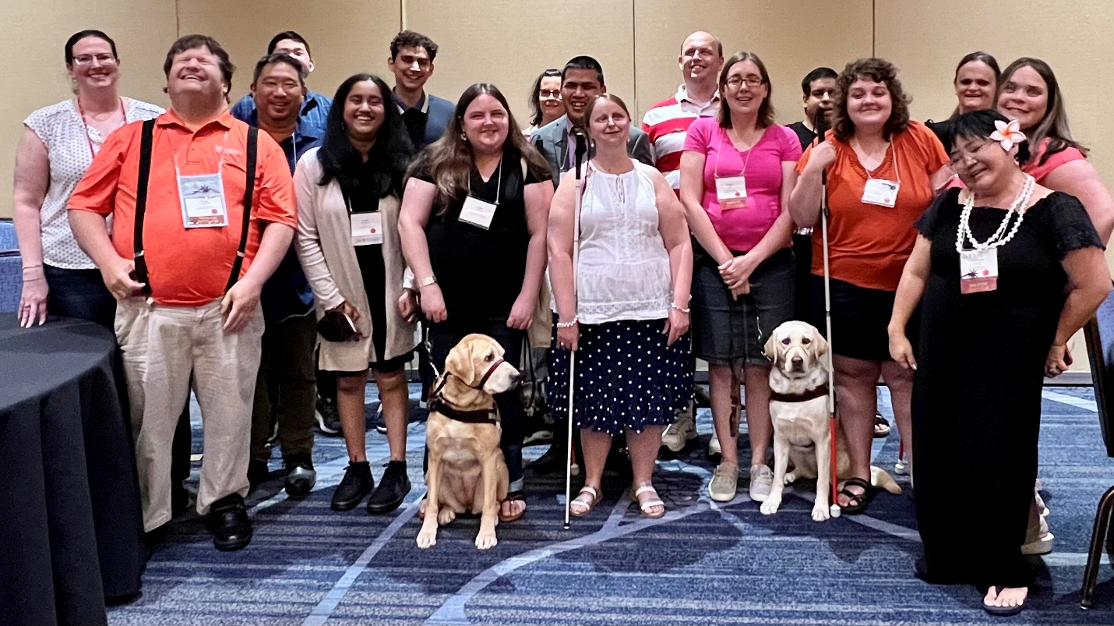
ACB Next Generation members and friends at the 2023 ACB NextGen Meet and Greet during the ACB Conference and Convention.

Left to Right: Melanie Sinohui, Gregg Wandsneider, Anthony Akamine, Matthew Cho, Swatha Nandakumar, Shane Aguilera, Claire Stanley and her guide dog, Maria Kristic, Benjamin Wright, Hindley Williams, Matt Selm, Lindsey Tilden and her guide dog, Niral Sheth, Kristen Kelling, Malaina VanderWal, TerriLynn Higashi, and Amanda Selm

The 2023 ACB Conference and Convention is in the books. ACB Next Generation had a nice contingent of members who attended the convention both in person in Schaumburg, IL and virtually. We caught up with a few members to find out about their convention highlights during and after the convention.
“It’s been fun, and I’ve made some great connections. I’ve also learned about some interesting technology. Being a vendor representing A. T. Guys, it can get a little busy and overwhelming in the exhibit hall. It brings a true perspective to being able to manage lots of products. Also, coming from a more rural area where I live, DoorDash is amazing to get things delivered right to my hotel room. I am an avid user of the Shokz OpenRun Pro headphones, and I use them with AIRA all the time. For those who didn’t know, AIRA had a map of the hotel and could guide you anywhere in the hotel.” – Michael Babcock
“The convention has gone quite well. I am an ACB/JPMorgan Chase Leadership Fellow, representing Penny Forward, and also a delegate for the ACB Government Employees special interest affiliate. I’ve enjoyed the programming I have attended as well. There are definitely things within the sessions that I have taken away and a few things that could have made them better. It’s been great, and I am honored to attend. I have also been super appreciative of the volunteers who have been around the hotel. It makes a big difference.” – Liz Bottner
“I am an exhibitor for the Penny Forward organization, so a lot of my convention was spent behind the table. I was also a member of the ACB mentoring program. I am also an alternate delegate for the Iowa affiliate. It’s been really exciting to meet all of the people I’ve talked to online and reconnect with some I met in Omaha last year. I am very thankful that I have some peripheral vision to help me navigate, but I’m still not perfect and get lost in the hotel at times.” – Moe Carpenter
“I only got to spend a few days at the convention this year, but I tried to make the most of it. I was honored to participate as a panelist in three NextGen sessions – one of which was virtual – on advocacy and communication. I also went on the tour of the Chicago History Museum and was impressed with how accessible the experience was for us. This included getting to touch several tactile items and hearing from very descriptive speakers. Plus, it was so neat to connect with several NextGen members I had never met in person. Finally, I squeezed in a Chicago Cubs game after waiting through a three-hour rain delay and got some amazing deep-dish pizza from Lou Malnati’s.” – Greg Lindberg
“My first time attending convention virtually was three years ago, and that is when I joined ACB next generation. I am so glad I did. Because of joining, I have made so many great friends, and I hope to meet all of them in person one day. This year, I attended convention virtually and really enjoyed the Sessions that had to do with audio description. I also enjoyed a presentation from Uber and what they are doing to make things accessible for people with disabilities. One night, I even facilitated a social on Zoom. I wasn’t sure how many people would show up, but I knew whomever would be there, we would have a great time just talking and getting to know each other more. It turns out about five people showed up, and we had a great time. Before we knew it, it was time to end. I am looking forward to convention next year and, no matter if I attend virtually or in person, I know I will enjoy it either way.” – Vika Trussell
“The convention was a fantastic experience as blind and low vision individuals came together from across the country to connect, decide policy, and learn from one another. There was a session for everyone, whether it was learning how to be more productive on the job, arts and crafts, networking mixers, and guide dog meetings. There is nothing quite so energizing as being part of such a diverse, open, and sincere group of people.” – Hindley Williams
***

A Photographic Glimpse into ACB NextGen at the 2023 ACB Conference and Convention

Note: Captions can be found to the right of or below each photo.

ACB NextGen Dining Out
Above: Group photo with 20+ ACB NextGen members and friends sitting at a long rectangle table while out to dinner at Maggiano’s. (Photo by Maggiano’s staff)

ACB NextGen Meet & Greet
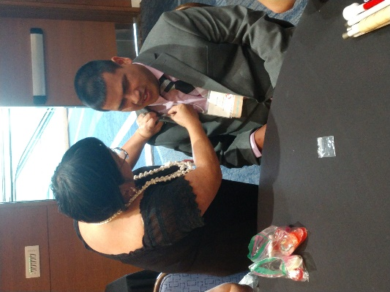
Left: TerriLynn Higashi pins the new ACB Next Generation Membership pin onto Ben Wright’s jacket lapel. (Photo by Melanie Sinohui)

Organization Program Panel
Left: Kenneth Semien, Sr, Hindley Williams and Michael Babcock shared their experiences and tips during the Organize Yourself: How to Get and Keep Your Ducks in a Row program. (Photo by Melanie Sinohui)
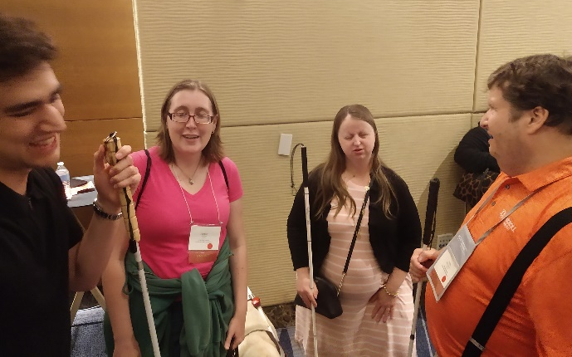
Friday Night Bash
Shane Aguilera, Lindsey Tilden, Hindley Williams and Gregg Wandsneider socialize during the Friday Night Bash. (Photo by Melanie Sinohui)

Tours
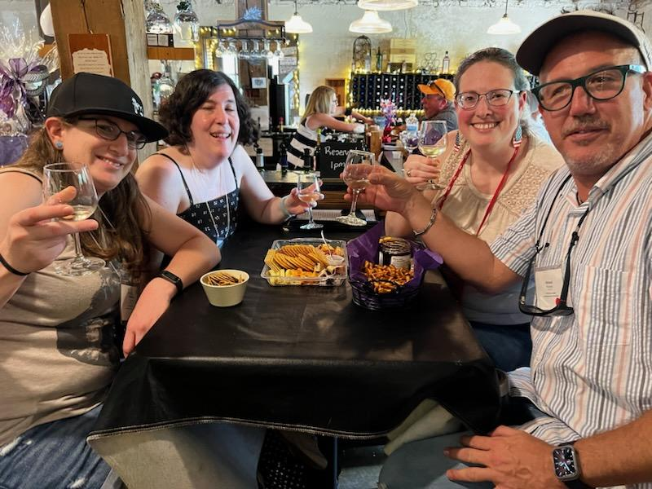
Left: Andi Thom, Dianna Leonard, Melanie Sinohui, and Mikey Wiseman wine taste at a high-top table filled with charcuterie, cheese curds, pretzels and jams at Northleaf Winery in Milton, Wisconsin. (Photo by Northleaf Winery staff)

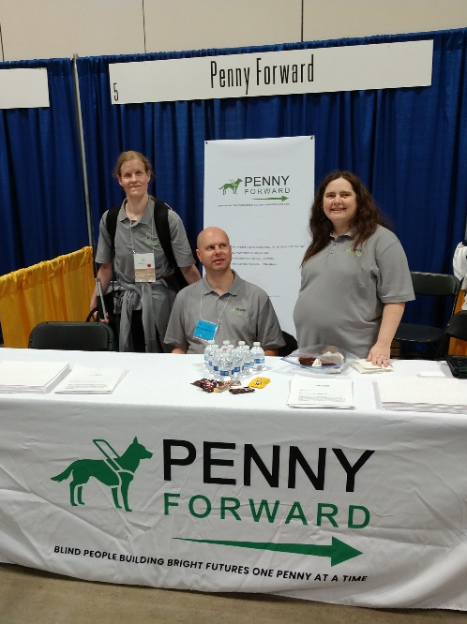
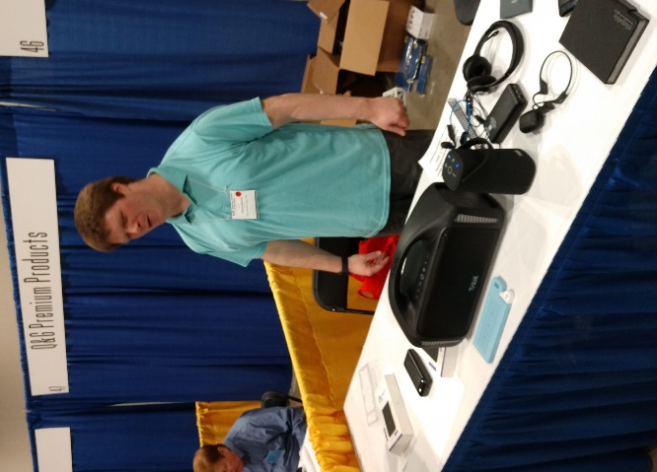
Exhibit Hall

Above: Michael Babcock mans the A. T. Guys booth and demonstrates their newest gadgets. (Photo by Melanie Sinohui) | Above: Liz Bottner, Chris Peterson, and Moe Carpenter represent Penny Forward at their booth. (Photo by Melanie Sinohui)

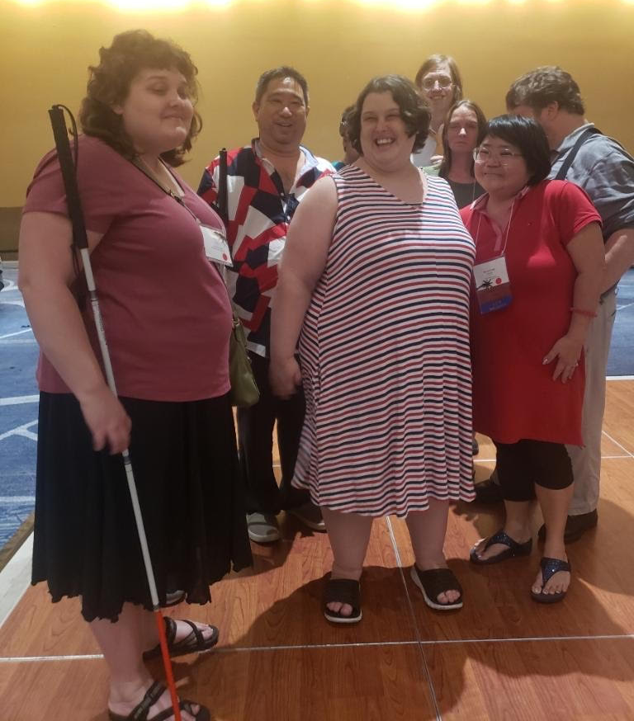
CCLVI Dance
Left: Kristen Kelling, Anthony Akamine, Amber Steet, Eric Malcolm, Katrina Teas, TerriLynn Higashi and Gregg Wandsneider pose on the dance floor during CCLVI’s Roarin’ 20’s dance. (Photo credit unknown)

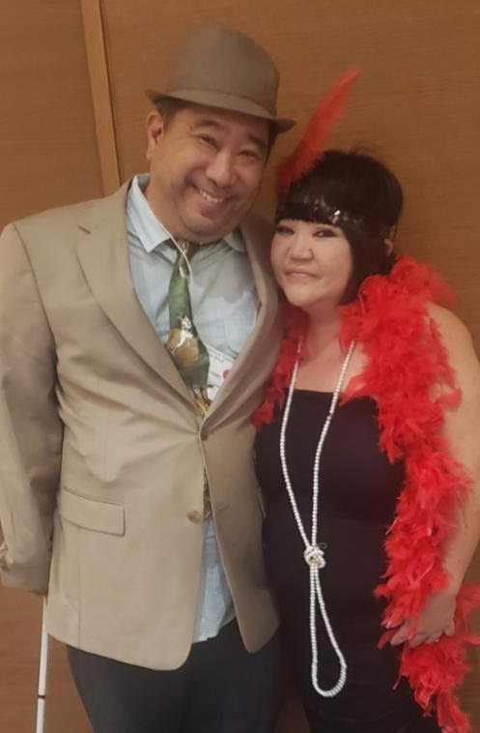
DKM Reception
Left: Anthony Akamine, ACB Next Generation member and Durward K McDaniel Fund Committee member, and TerriLynn Higashi dress up in their 1920s flare for the DKM Reception and Honor Society Induction Ceremony. (Photo credit unknown)

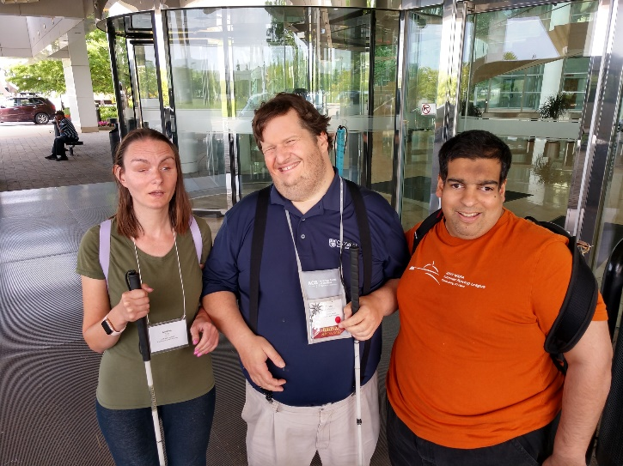
Bon Voyage
Left: Katrina Teas and Gregg Wandsneider pose with Niral Sheth outside the hotel as they wish him bon voyage on his trip back to Ohio. (Photo by Melanie Sinohui)

***

ACB NextGen Convention Door Prize and Swag Bag Donors
By ACB Next Generation Convention Committee

We would like to thank everyone who donated items for our convention swag bags and door prizes for the 2023 ACB Conference and Convention. We would like to recognize each donor below.

Swag Bag Donors:
- APH Career Connect – Richard Rueda
https://aphcareerconnect.org/
- Council of Citizens with Low Vision International (CCLVI)
https://cclvi.info/
- Georgia Council of the Blind (GCB)
https://georgiacounciloftheblind.org/
- TerriLynn Higashi Akamine
- Oregon Commission for the Blind (OCB)
https://www.oregon.gov/BLIND/Pages/index.aspx
- Cassie Trosper

Door Prize Donors:
- Shane Aguilera
- A. T. Guys – Michael Babcock
http://www.atguys.com
- Jessica Barr
- Blind Girl Designs – Tricia Waechter
http://www.blindgirldesigns.com
- Jennifer Bolling, a Pure Haven Consultant
https://purehaven.com/
TerriLynn Higashi Akamine
- Kentucky Council of the Blind Next Generation (KCBNG)
https://www.kentucky-acb.org/nextgeneration
- Lindsey LaVere
- DJ McIntyre
- Amanda Selm
- Matt Selm
- Melanie Sinohui
- Starbucks (Phoenix, AZ)
- Cassie Trosper
- WayAround - Jessica Hipp
http://www.wayaround.com

***
Cosmic Committee Corner: Convention Committee
Co-Chairs: Melanie Sinohui and Cassie Trosper
Contact: convention@acbnextgeneration.org
The ACB Next Generation Convention Committee takes programming to a whole new level. While this committee is not active all 12 months of the year, we pack a lot of punch into a short period of time. Together, we brainstorm programming for the annual ACB Conference and Convention with a focus on a balance of social and educational event opportunities. We develop the content and partner with other affiliates and subject-matter experts to ensure each event is well rounded. We develop the promotion plan to partner with the Public Relations/eCommunications Committee to ensure we broadcast the events and fundraising opportunities to our membership and beyond through such channels as social media, YouTube teasers, radio spots on ACB Media, and our website. We are always looking for new partners who are doers and are driven to get a lot of work done in a short period of time and who want the biggest sense of accomplishment and pride at the conclusion of convention week each July.

***

Fundraising Update
This is Moe with your midyear fundraising update. We have been shooting for the moon and have landed among the stars. Not only was the spring auction a huge success, but we also hit our Double Good Popcorn fundraiser goal and are currently 68% of the way to our Brenda Dillon Memorial Walk goal!
I am sure you are all scratching your heads now and wondering why I am so excited about only being 68% to our walk goal. That’s because the walk isn’t over yet. That’s right. By the time this newsletter is released, we will still have an entire month – and then some – to show how amazing the ACB Next Generation All-Stars are. I’m sure we can reach our goal.
Why should you join or donate to our walk team? I’m so glad you asked. Hopefully there are some great pictures that were taken at the in-person event, but the in-person walk is only part of the fun. We want to show that ACB NextGen supports the ACB Get Up and Get Moving Committee and that we value our health. Also, for anyone who donates or joins the team, you’ll have the chance to win one of four $20 gift cards. Of course, you’ll also be helping NextGen turn our dreams into a reality.
From the Fundraising Committee, we would also like to thank all of you who have supported our major events during the first half of the year, including the Spring into Auction at the end of April, and the Double Good Popcorn event in June. The walk will be our big event for this third quarter, and we will wrap up the year with one more event that has yet to be determined. We also have some ongoing items you can sign up for, and we encourage you to reach out if you have any questions on what these are. We have tried to arrange a variety of ways through which you can help build NextGen financially, so we ask for your engagement to help us guide you with what works best for you.
Again, thanks so much for your support. If you ever have any questions, please send us an email at fundraising@acbnextgeneration.org. We would love to hear your questions and comments.
Now, let’s finish this last half of the walk by hitting our goal out of the park! Visit the walk page at:
https://secure.qgiv.com/event/acbwalk2023/team/922786/.

***

KCB Next Generation Update
By Joey Couch
Greetings everyone from the Bluegrass State and the Kentucky Council of the Blind Next Generation,
We have had a busy first half of 2023. Firstly, in January, we held a Zoom call about accessible games and other items that one can do with I-devices. In February, we put on another Zoom call with members from the Diversity, Equity, and Inclusion Committee. These included Koni Sims, Kenneth Semien, Sr., Cheryl Cummings, and Regina Brink. Then this past March, we were joined by Pam Shaw, Debby Green, and other members from ACB’s Mental Health and Wellness Committee where we discussed topics like how to deal with burnout, how to set boundaries, and other related subjects. In April, we held an event on spring cleaning and getting organized with built-in smartphone tools and other useful apps.
We also had our spring dine-out at a home cooking-style restaurant. These dine-outs are enjoyed by one and all. We usually will pick some establishment that people usually don’t get to make it to, and we will make an afternoon of it. We normally do about three of these per year if constraints permit. It is a good way for people in our local chapter, as well as anyone else who wishes to join us, to catch up with one another and see how everyone is doing overall.
As of this writing, four of our members were planning to attend the ACB Conference and Convention in person in Schaumburg, IL.
Our Zoom calls are held on the fourth Thursday of the month unless otherwise specified. Make sure that you are subscribed to the ACB next generation email list because reminders are sent out about these calls to that list so that one and all can participate if they wish to do so. Everyone is welcome. You can also follow us on Facebook at https://www.facebook.com/KCBNextGen.

***

NextGen101 Roles Out the Red Carpet

If you have not had the chance, consider joining us for our NextGen 101 events.
The Membership Committee held its first event in February. The events are held quarterly. NextGen 101 seeks to give our new members – and those who are NextGen curious – the chance to meet one another, learn more about NextGen's programs and activities, and ask their questions. The first event in February focused on folks learning about our Assistive Technology Grant and Mentoring Program. In May, we learned more about our NextGen Auction and upcoming activities at the ACB Conference and Convention. We also discussed how members could obtain financial assistance to cover their registration costs.
Our next event will be on Wednesday, August 2 at 8 p.m. ET. We hope you will join us, and please bring a friend!

***

You’re Invited: 2023 Committee Showcases

Are you trying to find your place in ACB Next Generation? Are you wanting to try something new while also contributing to the affiliate?

The ACB Next Generation board and committee chairs invite you to the 2023 committee showcases. Committee chairs will present the exciting work they do to help the affiliate thrive. There will be opportunities to ask questions and learn more about each committee.
The Committee Showcases will be held on two different days, August 1 and August 8, both at 9 p.m. ET. This format is designed to give each committee chair enough time to share about their activities and for guests to ask questions to determine which committee might be best for them. Be on the lookout for more details and the Zoom info for each session.

***

Tech Tip: Eleven Labs
By Michael Babcock

The use of technology has revolutionized the way we communicate and interact with others. One of the most exciting innovations in the tech world is the use of text-to-speech tools, which have made it possible to convert written text into spoken words. Eleven Labs is an AI-based company that has taken this technology to the next level by offering a variety of voices for users to choose from.

At the 2023 ACB conference and convention, attendees were impressed with the use of Eleven Labs' text-to-speech tool to have important material read aloud. The clear and easy-to-understand text-to-speech audio produced by Eleven Labs was a hit with the attendees.

One of the unique features of Eleven Labs is the ability to clone a person's voice with just 15 minutes of audio. While this feature is not yet perfect, it has the potential to revolutionize the way we communicate and interact with others. Imagine being able to have a virtual assistant that sounds just like you!

There are several ways to use Eleven Labs, including having lengthy information read aloud during conventions. I have used Eleven Labs to convert minutes into audio for our local chapter of the Oregon affiliate. The process is simple and straightforward, and the resulting audio is clear and easy to understand.

In conclusion, Eleven Labs is a great way to produce audio from text in an easy and clear means. With its variety of voices and ability to clone a person's voice, it has the potential to revolutionize the way we communicate and interact with others. If you haven't tried Eleven Labs yet, I highly recommend giving it a try!

***

ACB Next Generation’s Maria Kristic wins Writing Award at ACB Conference and Convention

At the 2023 ACB Conference and Convention in Schaumburg, Illinois, Maria Kristic, ACB Next Generation Treasurer, won the Ned E. Freeman Excellence in Writing Award for her article, Glimpses of Croatia.

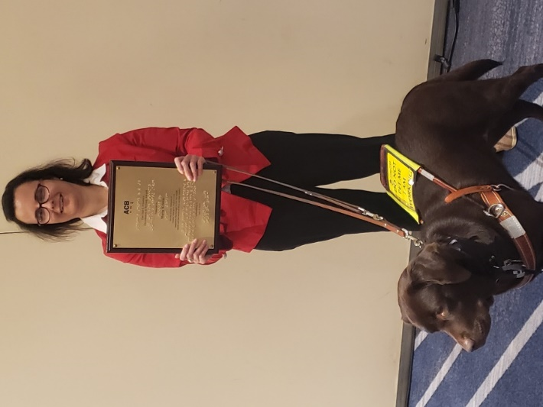
Caption: Maria is standing with her guide dog at her feet, holding her plaque. (Photo by TerriLynn Higashi)

Glimpses of Croatia
By Maria Kristic
Chair, ACB International Relations Committee

“Reach up with your right hand,” my mom said as we exited the apartment. I stopped and did what she suggested, feeling a tree and the long pod which grew on it. I didn’t think it was a pea plant, but had no idea what else it could be. “What is it?” “Carob,” she replied. “Carob!” I practically squealed in surprise and delight — this ingredient which I had been using as a chocolate substitute in homemade treats for my guide dog, and which I had only seen in powder or chip form, was growing fresh literally feet from where I was staying!

I immigrated to the United States with my parents and brother from Bosnia in 1993 during the war there. With the nearly identical language in neighboring Croatia and the fact that we are ethnically Croat, several of my family members had relocated there during that time. While I have made several trips, only recently, during my visits in the summers of 2016 and 2021, have I really begun to appreciate this country. My paternal aunt’s property in the city of Split on the Dalmatian coast includes olive and caper groves, and the olive oil, with its strong, sharp, fresh taste is just divine! Speaking of Split, Diocletian’s Palace, a complex built in the 4th century CE for the Roman emperor, was a standout for me. The complex is a bustling hive of activity today with restaurants, shops, and residents going about their day on its narrow, waterfront streets. The sounds of music from the restaurants and the chatter of people fill the air. However, walking the empty basements of the palace structure itself, where one entrance came straight from the harbor to facilitate the unloading and storage of goods, was such a haunting experience. As my footsteps echoed, I felt awe knowing that I was walking a path which has existed for thousands of years, and I pictured servants manually carrying in barrels of wine and oils.

I have spent much time in Makarska, a town also on the Dalmatian coast and located about 40 miles south of Split, as my parents recently purchased an apartment there — the apartment near the carob trees. Those are not the only trees around town; olive, fig, and pomegranate trees, along with their blooming fruits, can also be touched as one walks around. My most recent trip in 2021 was my first time staying in the apartment. Having our own place to stay instead of moving between different family members’ homes, as we had done before, meant I could explore with my family in a more leisurely way. I swam in the Adriatic Sea, usually in the mornings or afternoons when the sun was not as strong, marveling at how clean the water felt! I am told the cleanliness produces beautiful colors visually and allows viewers to see the bottom of the sea. Even my guide dog, a Lab who loves to swim, got to take a couple of happy dips, though I only allowed it because there was an outdoor shower mere feet away with which I could clean the salt off her immediately afterward. Various beach activities are offered, from diving to kayaking to jet skiing to water activities for children and beyond. While the waves are usually gentle, sudden winds are known to come — the northern bura and southern jugo (pronounced yugo) — and indeed, a jugo derailed my brother’s and my plan to try paragliding one morning.

On most evenings, we would walk along the Riva, or waterfront promenade, the smell of sea salt and seafood in the air. On one side would be the sound of gentle waves, while music from the myriad outdoor cafes on the shore could be heard on the other. Sometimes, music could also be heard from boats on the sea side, as these vessels, which offered excursions to Croatian islands during the day, became docked “restaurants” for seafood dinners in the evening. I have eaten a delicious fish called skuša (pronounced skoosha), a type of mackerel native to Croatia, on one such evening dinner, to the sounds of classic Croatian music hits and seagulls circling and crying out overhead, waiting for a tasty morsel to drop in the water. This being the coast, there were plenty of seafood dishes to try. I had a shrimp buzara (meaning sautéed in olive oil, parsley, garlic, and white wine), and I noticed that the shrimp was more meaty and chewy than what I have eaten in the United States. I also ate a lobster brudet (a stew with seafood, potatoes, tomatoes, garlic, white wine, olive oil, parsley, black pepper, and saffron). I was not brave enough to try shark! Elsewhere in town, I have also traveled on some cobblestoned, pedestrian-only town streets which were so narrow that I could spread my arms wide and touch the buildings on each side!

As I explored Makarska with my family, I noticed that the structure of curbs was slightly different from those in the U.S. — rather than a sharp-edged curb and curb cut ramp, they tended to be all-in-one, curb-like structures but with rounded edges, somewhere between a curb and a ramp. Also, instead of outdoor stairs being made accessible with a pure ramp, the structure tended to be a ramp overall but with intermittent, rounded protrusions, almost like small speed bumps. These took some getting used to, and between the structure change and the new environment, I did initially have to do some repetition work with my dog to ensure that she understood what these elevation changes were. I did encounter one accessible pedestrian signal. While people I encountered in businesses did not generally visually recognize the guide dog harness, I had surprisingly few access issues, and if I did, most times, explaining that she was a guide dog sparked some recognition of the term and resolved the issue. My maternal aunt, who lives there, tells me there is a guide dog user resident, so I imagine that she and the guide dog school in Croatia have done some of the advocacy to make this level of awareness possible. I did have two consecutive access denials at hotels in Split in 2016 when we unexpectedly found ourselves needing a hotel for one night, with the owners telling me they did not care about the law; realizing that I would not win those battles at that moment, I tried other hotels and finally had a wonderful experience with the third location.

I visited with my dad and brother Sveti Jure (pronounced Yureh) (St. George), the second highest peak in Croatia, although counting the satellite, radar, and other observational antennas which are stationed there, it is the tallest point at 5,780 feet above sea level. As my dad drove up the narrow and twisty road, with the windows open, the sweet and woodsy aroma of trees filled my nostrils as the temperature noticeably cooled. We passed wild horses and goats grazing. We had to hike over some rocks the last few feet to the peak. Standing there, with the sounds of birds and leaves and almost no cars, I felt such serenity, peace, and connectedness with nature.

I’ve had other experiences, too. On the island of Pag, I got to taste the deliciously salty and flavorful native cheese, made so by the bura blowing salt from the Adriatic onto the island grass on which the sheep graze. My dog was very interested in the group of swans in a small lake which we passed several times on our visit; I wished I could have pet one! I’ve visited Plitvice Lakes National Park, hiking with my guide dog carefully on trails with no rails or safety signs, taking a boat ride on one of its lakes, and hearing the rush of its waterfalls, though I am told they are even more active in other months of the year. A poignant moment came when we were leaving the park, and a cute stray dog, seeing mine, started following us to our car; I wished I could have taken it home! I’ve listened to the otherworldly sound of the Zadar Sea Organ, a musical instrument created in the sea using marble steps with tubes placed under them, such that the sea waves create music. In the historic town of Mali Ston, I heard morning church bells from a medieval era church which have been ringing every morning for the past 700 years, felt lemons on their trees, ate figs and apricots fresh from their trees, and touched one of the loaded salt wagons which bring the mineral to the town.

Even with all this, I have so much more to visit on my next trips — the islands, the capital, Zagreb, Pula with its Roman amphitheater, Dubrovnik with its rich history and status as a UNESCO World Heritage site, the Sinjska Alka knight’s tournament spectacle which has been happening since 1715 to commemorate a Croatian victory over Ottoman invaders. Have I enticed you to visit yet, or at least do some research?
Editor’s Note: This article is reprinted with permission from ‘The ACB E-Forum,’ December 2022. We congratulate Maria on receiving the Ned E. Freeman Excellence in Writing Award for this great piece at the 2023 ACB Conference and Convention!

***

Calendar of Events
Everyone is welcome to attend these events by accessing the Zoom mobile app, visiting the Zoom website at https://zoom.us, or calling (312) 626-6799, and entering the appropriate meeting ID and passcode.

You may sign up to receive reminders and Zoom details by subscribing to the ACB Next Generation email list. Please send a blank email to main+subscribe@acbnextgeneration.groups.io

In addition, many ACB Next Generation events are listed on the ACB Community Call schedule.

July
15 - July NextGen Insight published
18 - Monthly Education Program (Advocacy Part 3) - 8 p.m. ET
22 - Saturday Night Live Hangout - 7 p.m. ET
25 - Q3 Committee Chairs Meeting - 8 p.m. ET

August
1 - Committee Showcase Part 1 - 9 p.m. ET
2 - NextGen 101 Orientation - 8 p.m. ET
8 - Committee Showcase Part 2 - 9 p.m. ET
14 - ACB Next Generation Board Meeting - 8 p.m. ET
15 - Monthly Education Program - 8 p.m. ET
26 - Saturday Night Live Hangout - 7 p.m. ET
September
11 - ACB Next Generation Board Meeting - 8 p.m. ET
19 - Monthly Education Program - 8 p.m. ET
23 - Saturday Night Live Hangout – 7 p.m. ET

October
3 - Q4 Committee Chairs Meeting - 8 p.m. ET
4 - Deadline to submit proposed amendments
9 - ACB Next Generation Board Meeting - 8 p.m. ET
15 - October NextGen Insight published
17 - Monthly Education Program - 8 p.m. ET
28 - Saturday Night Live Hangout - 7 p.m. ET

***
The NextGen Insight is published four times per year:
(January 15, April 15, July 15, and October 15) in a digital format via email and posted to our website the following month. Send newsletter items for consideration to publications@acbnextgeneration.org.
***

ACB Next Generation Board of Directors
President - Amanda Selm
1st Vice President - Matt Selm
2nd Vice President - Melanie Sinohui
Secretary - Cassie Trosper
Treasurer - Maria Kristic

Director - Shane Aguilera
Director - Moe Carpenter
Director - Kristen Kelling
Director - Lindsey LaVere
Director - Hindley Williams

***

How to Reach Us
Email Address: ACBNextGen@gmail.com
Phone Number: (202) 524-0909
Website: http://www.acbnextgeneration.org
Social Media:
http://www.acbnextgeneration.org/contact-us
ACB NextGen Blog: http://www.acbnextgeneration.org/blog

